Appendix 4.4
Matua field logs
Sample | Peak strength (kPa) | Remoulded strength (kPa) | Sensitivity
M1 | 60 | 4 | 15
M1 | 60 | 4 | 15
M1 | 71 | 5 | 14.2
M1 | 66 | 5 | 13.2
M1 | 46 | 3 | 15.3
M1 | 70 | 4 | 17.5
Mean | 63.0 | 4.8 | 13.9
Standard Error | 5.3 | 1.0 | 1.8
Field peak shear vane strength, remoulded shear vane strength and calculated sensitivities are presented for M1.
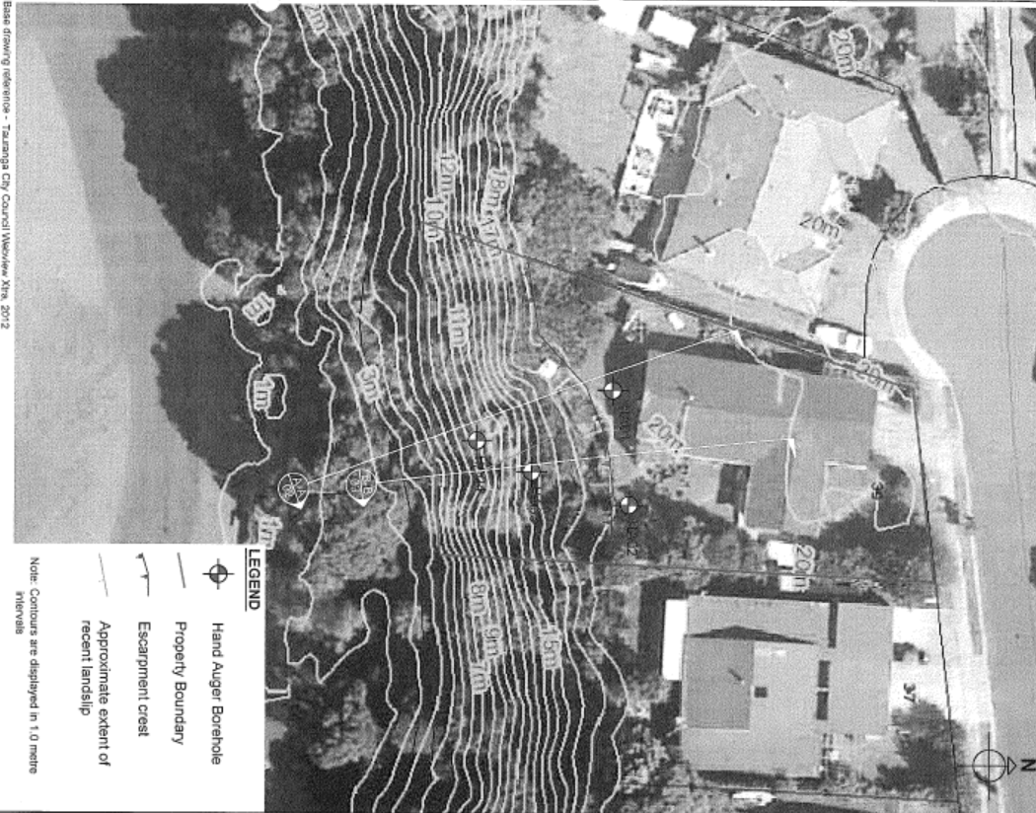
Site plan, cross sections A-A and B-B, & hand auger boreholes 1-4 for Site 2: Matua (Coffey Geotechnics, 2013).

