Appendix 2

Mandible plasticity and adaptations of New Zealand Mustela erminea mandibles across locations
Expected centroid seize | CP | 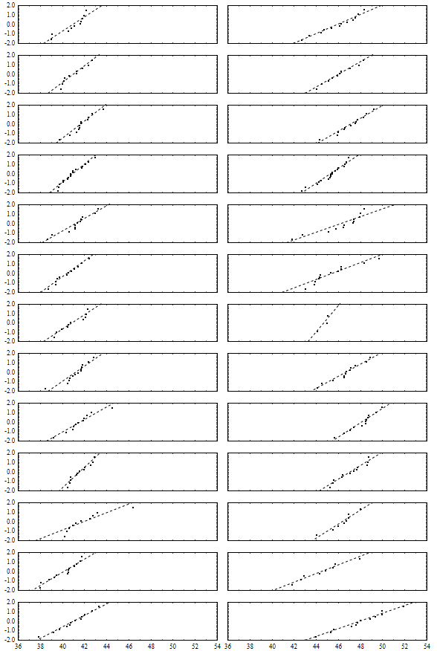
Expected centroid seize | PU
Expected centroid seize | AP
Expected centroid seize | WL
Expected centroid seize | MC
Expected centroid seize | HVN
Expected centroid seize | HVY
Expected centroid seize | EVN
Expected centroid seize | EVY
Expected centroid seize | GV
Expected centroid seize | SI
Expected centroid seize | RI
Expected centroid seize | EN
 |  | Female | Male
 |  | Observed centroid size (mm)
Figure 1.1. Normal probability plots generated as part of the centroid size ANOVAs comparing male and female stoats from different locations around New Zealand and one English location.

Regression score 1 | CP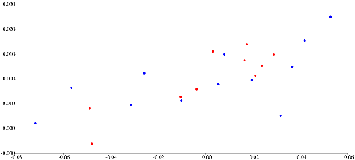 | PU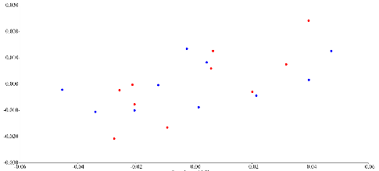
Regression score 1 | AP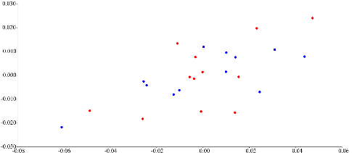 | WL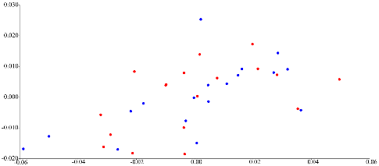
Regression score 1 | MC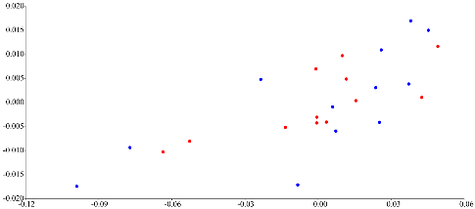 | EVN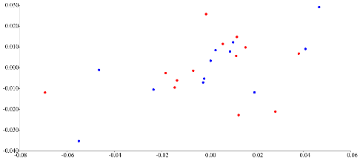
Regression score 1 | GV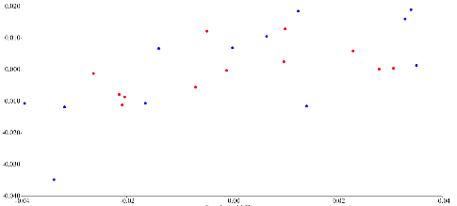 | SI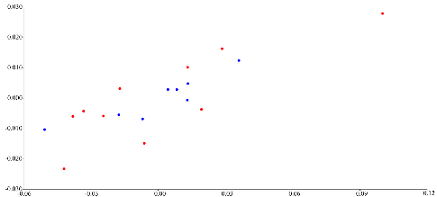
Regression score 1 | RI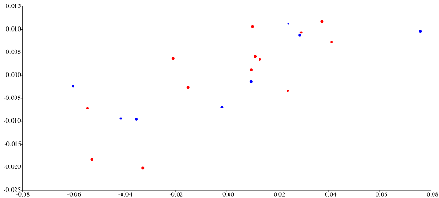 | EN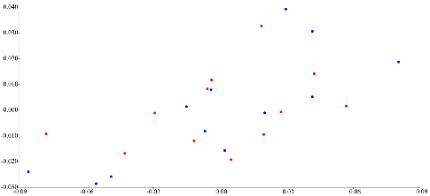
 | Log centroid size
Figure 1.2. Pooled-within group regression analysis of shape and log centroid size, as a test for allometry on stoats from around New Zealand and One Enlish location, males: blue, females: red. The associated statistics for this regression can be found in Table 1.

Table 1. Pooled within-group (sex) regression analyses of mandible shape and centroid size as a test for allometry, The permutation test p-value is against the null-hypothesis, significant values (p<0.05) are highlighted in bold.
 | Total SS | Predicted SS | Residual SS | d.f. | % predicted | Permutation test p-value (10000 runs)
CP | 0.0282 | 0.0016 | 0.0266 | 1, 20 | 5.7500 | 0.2599
PU | 0.0321 | 0.0009 | 0.0312 | 1,18 | 2.7000 | 0.9131
AP | 0.0361 | 0.0015 | 0.0347 | 1, 22 | 4.1100 | 0.4695
WL | 0.0540 | 0.0015 | 0.0525 | 1, 34 | 2.7000 | 0.4983
MC | 0.0283 | 0.0011 | 0.0273 | 1, 22 | 3.7100 | 0.5952
HVN | 0.0336 | 0.0031 | 0.0305 | 1, 22 | 9.2000 | 0.0108
EVN | 0.0390 | 0.0013 | 0.0377 | 1, 23 | 3.2900 | 0.6373
GV | 0.0306 | 0.0015 | 0.0292 | 1, 22 | 4.8300 | 0.3223
SI | 0.0246 | 0.0017 | 0.0228 | 1, 16 | 7.0100 | 0.2739
RI | 0.0217 | 0.0010 | 0.0207 | 1, 19 | 4.7900 | 0.5130
EN | 0.0422 | 0.0033 | 0.0389 | 1, 22 | 7.9100 | 0.0575

Principal component 2 | CP 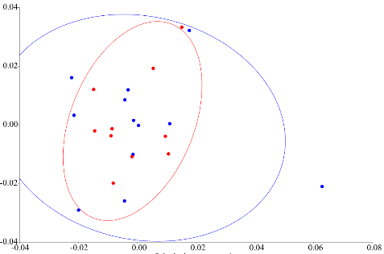 | PU 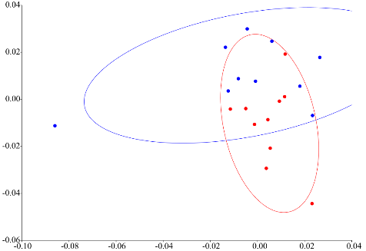
Principal component 2 | AP 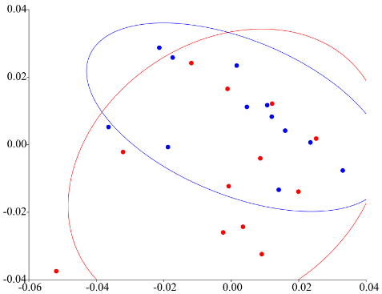 | WL  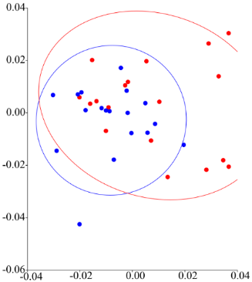
Principal component 2 | MC 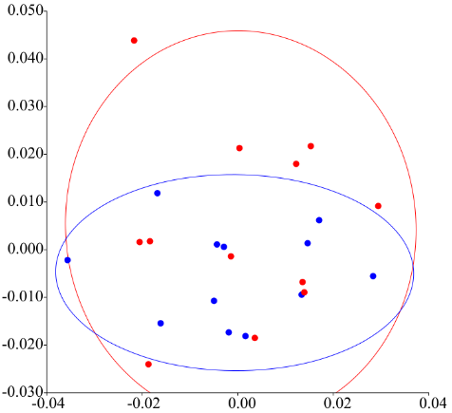 | HVN 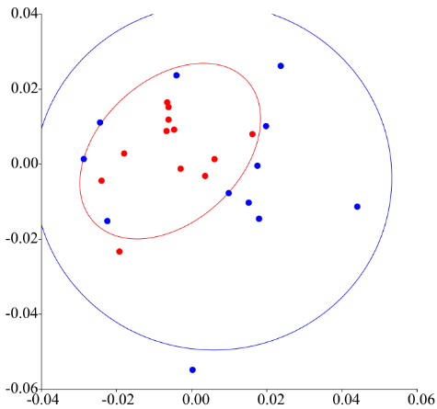
Principal component 2 | EVN 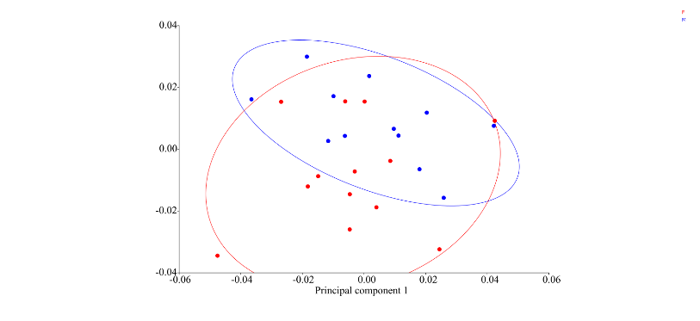 | GV 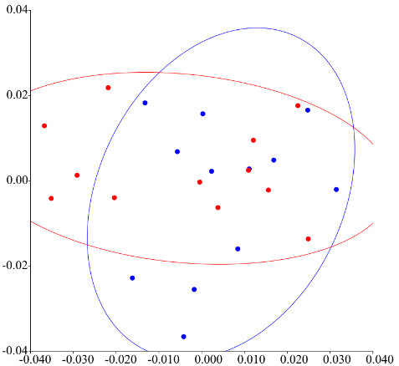
Principal component 2 | SI 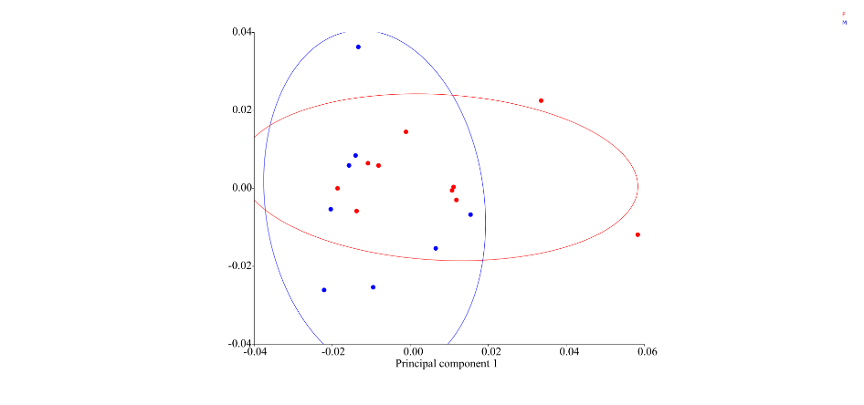 | RI 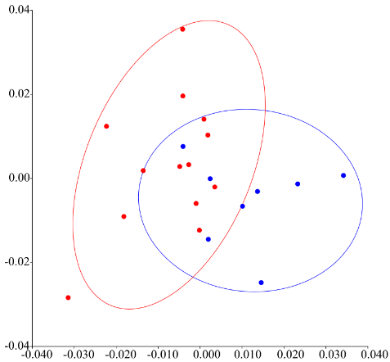
Principal component 2 | EN 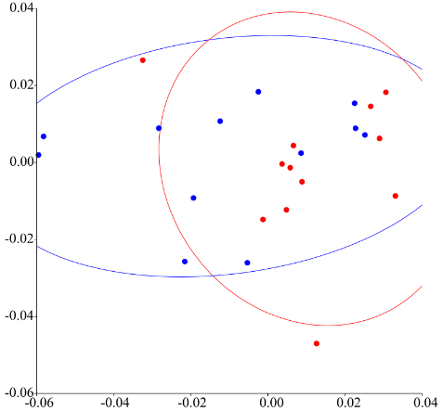
 | Principal component 1
Figure 1.3. Composite figure of the PCAs of male and female stoat mandibles from 11 locations, before allometric correction. Circles indicate the 90 % confidence ellipses. Males: blue, females: red.

Variance (%) | CP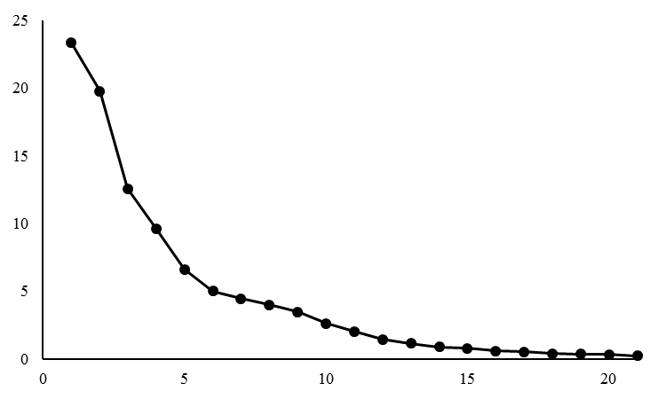 | PU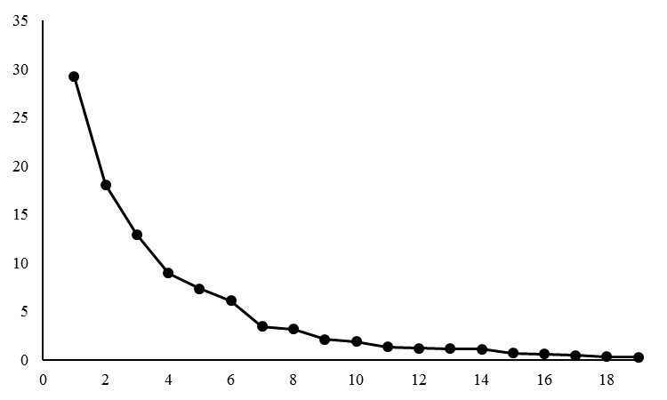
Variance (%) | AP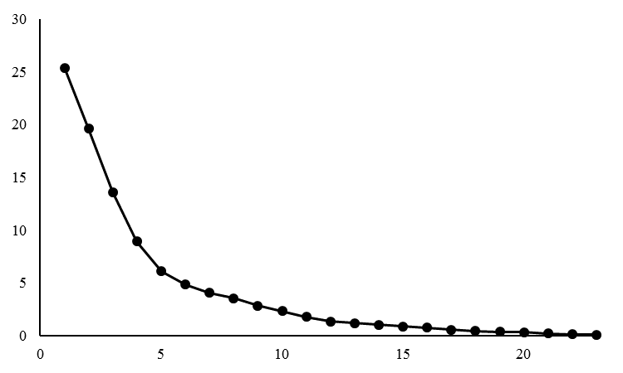 | WL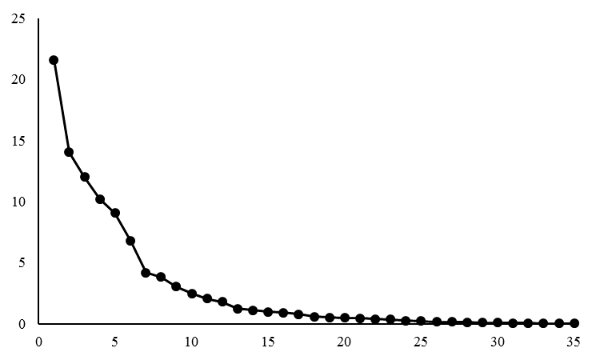
Variance (%) | MC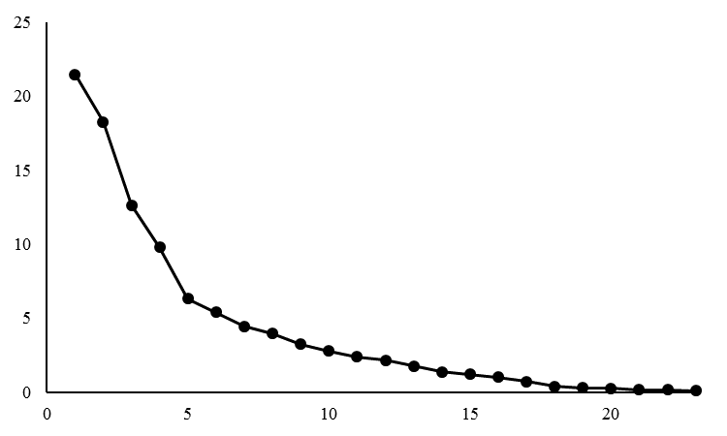 | HVN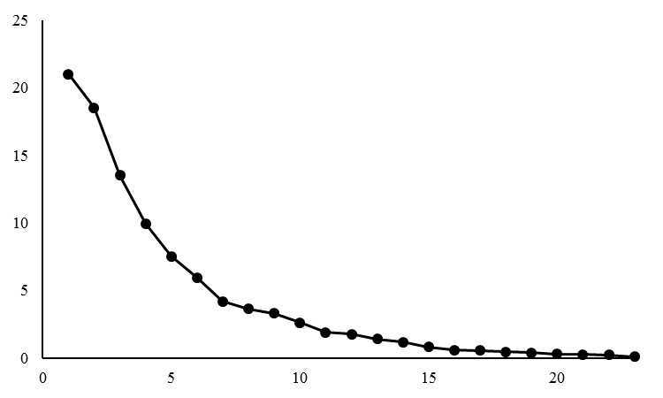
Variance (%) | EVN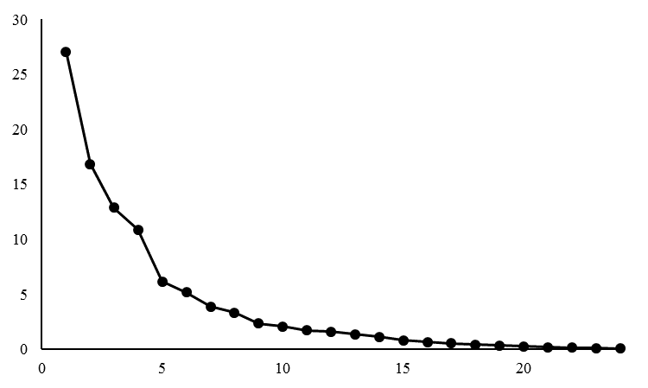 | GV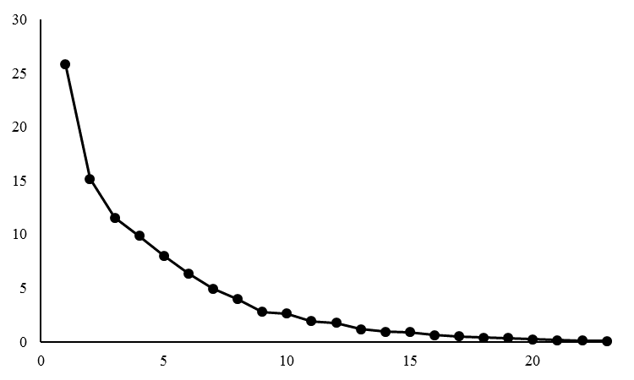
Variance (%) | SI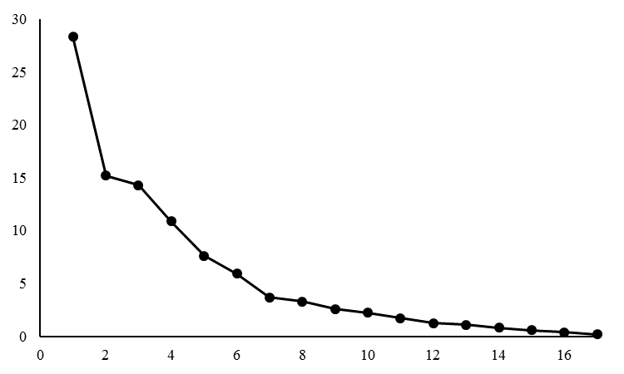 | RI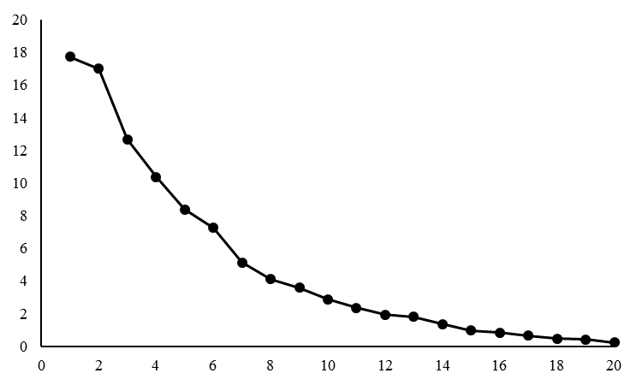
Variance (%) | EN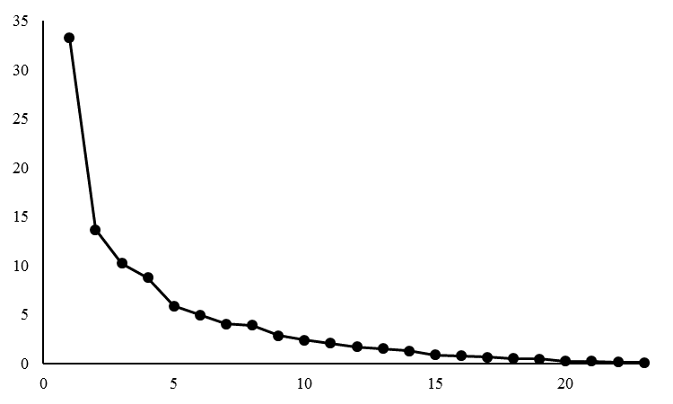
 | Principal components
Figure 1.4. Composite figure of the eigenvalue and percentage of variance scree plot from the male and female PCAs (see above), before allometric correction from 11 locations.

Table 2. Eigenvalues relating to the within location PCA, Hollyford valley results from both prior to and after allometric correction were included, eigenvalues that account for five percent or more of the variance were reported, significant eigenvalues (χ2<5.99) are highlighted in bold, and eigenvalues before the inflection point on the scree graphs are italicised.
 |  | EV1 | EV2 | EV3 | EV4 | EV5 | EV6 | EV7
CP | Eigenvalue | 0.0003 | 0.0003 | 0.0002 | 0.0001 | 0.0001 | 0.0001
CP | Variance (%) | 23.3500 | 19.7580 | 12.5640 | 9.6250 | 6.6180 | 5.0070
CP | Cumulative % | 23.3500 | 43.1080 | 55.6730 | 65.2980 | 71.9150 | 76.9220
PU | Eigenvalue | 0.0006 | 0.0003 | 0.0002 | 0.0002 | 0.0001 | 0.0001
PU | Variance (%) | 29.1740 | 18.0460 | 12.9330 | 8.9390 | 7.3200 | 6.0770
PU | Cumulative % | 29.1740 | 47.2210 | 60.1540 | 69.0920 | 76.4120 | 82.4890
AP | Eigenvalue | 0.0004 | 0.0003 | 0.0002 | 0.0002 | 0.0001
AP | Variance (%) | 25.3830 | 19.6000 | 13.5950 | 8.9100 | 6.0830
AP | Cumulative % | 25.3830 | 44.9830 | 58.5780 | 67.4880 | 73.5710
WL | Eigenvalue | 0.0004 | 0.0002 | 0.0002 | 0.0002 | 0.0001 | 0.0001
WL | Variance (%) | 21.6140 | 14.0290 | 12.0010 | 10.2210 | 9.0620 | 6.7750
WL | Cumulative % | 21.6140 | 35.6430 | 47.6440 | 57.8640 | 66.9270 | 73.7010
MC | Eigenvalue | 0.0003 | 0.0002 | 0.0002 | 0.0001 | 0.0001 | 0.0001
MC | Variance (%) | 21.4770 | 18.2620 | 12.6250 | 9.7680 | 6.3030 | 5.3770
MC | Cumulative % | 21.4770 | 39.7390 | 52.3640 | 62.1320 | 68.4350 | 73.8120
HVN prior to allometric correction | Eigenvalue | 0.0003 | 0.0003 | 0.0002 | 0.0002 | 0.0001 | 0.0001
HVN prior to allometric correction | Variance (%) | 21.0100 | 18.5270 | 13.5040 | 9.9320 | 7.5120 | 5.9490
HVN prior to allometric correction | Cumulative % | 21.0100 | 39.5360 | 53.0400 | 62.9730 | 70.4850 | 76.4340
HVN after allometric correction | Eigenvalue | 0.0006 | 0.0003 | 0.0002 | 0.0001 | 0.0001
HVN after allometric correction | Variance (%) | 35.0390 | 14.8480 | 12.3070 | 7.1940 | 6.4120
HVN after allometric correction | Cumulative % | 35.0390 | 49.8870 | 62.1950 | 69.3890 | 75.8010
EVN | Eigenvalue | 0.0005 | 0.0003 | 0.0002 | 0.0002 | 0.0001 | 0.0001
EVN | Variance (%) | 27.0560 | 16.8580 | 12.8830 | 10.8700 | 6.1370 | 5.1540
EVN | Cumulative % | 27.0560 | 43.9140 | 56.7970 | 67.6670 | 73.8030 | 78.9570
GV | Eigenvalue | 0.0004 | 0.0002 | 0.0002 | 0.0001 | 0.0001 | 0.0001
GV | Variance (%) | 25.8200 | 15.1600 | 11.5410 | 9.8680 | 8.0120 | 6.3400
GV | Cumulative % | 25.8200 | 40.9800 | 52.5210 | 62.3890 | 70.4010 | 76.7410
SI | Eigenvalue | 0.0004 | 0.0002 | 0.0002 | 0.0002 | 0.0001 | 0.0001
SI | Variance (%) | 28.3180 | 15.2030 | 14.2770 | 10.8540 | 7.6280 | 5.9370
SI | Cumulative % | 28.3180 | 43.5200 | 57.7980 | 68.6520 | 76.2800 | 82.2170
RI | Eigenvalue | 0.0002 | 0.0002 | 0.0002 | 0.0001 | 0.0001 | 0.0001 | 0.0001
RI | Variance (%) | 17.7190 | 16.9970 | 12.6720 | 10.3670 | 8.3700 | 7.2400 | 5.1380
RI | Cumulative % | 17.7190 | 34.7160 | 47.3880 | 57.7550 | 66.1250 | 73.3650 | 78.5030
EN | Eigenvalue | 0.0007 | 0.0003 | 0.0002 | 0.0002 | 0.0001
EN | Variance (%) | 33.2190 | 13.6600 | 10.2160 | 8.7250 | 5.8470
EN | Cumulative % | 33.2190 | 46.8800 | 57.0950 | 65.8200 | 71.6670

CP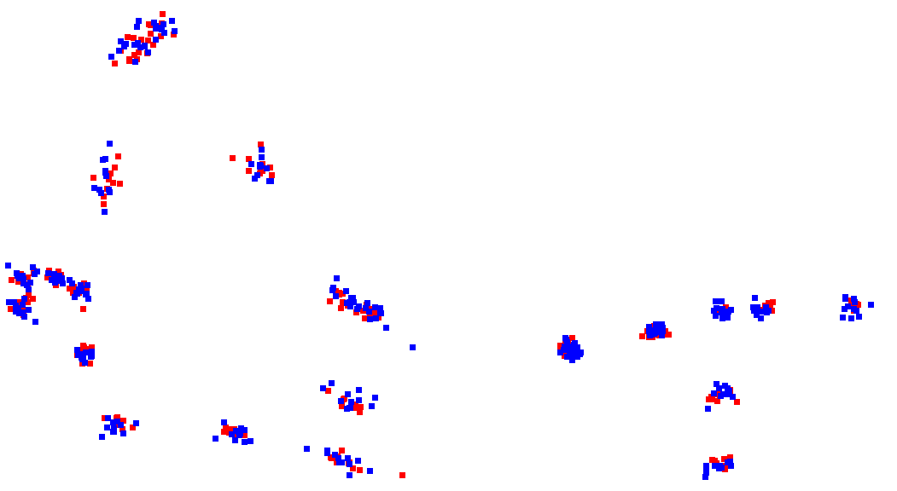 | 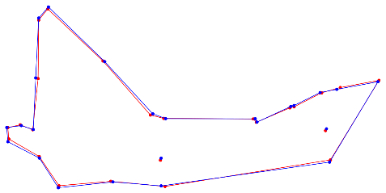
PU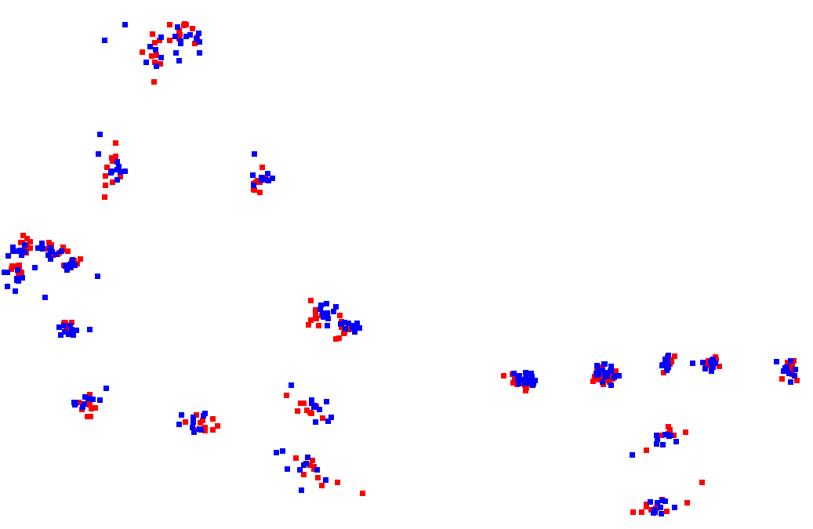 | 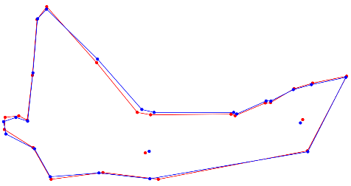
AP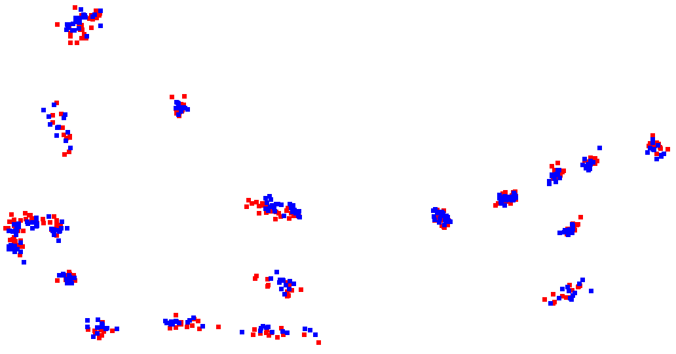 | 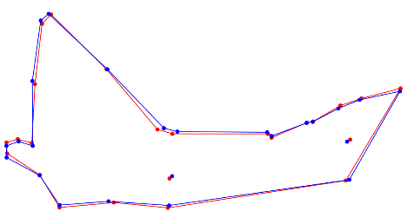
WL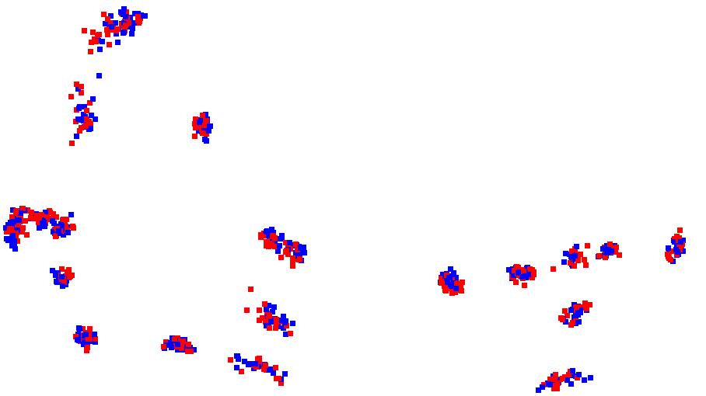 | 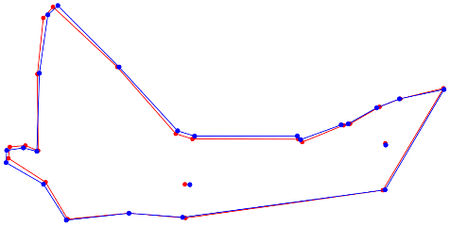
MC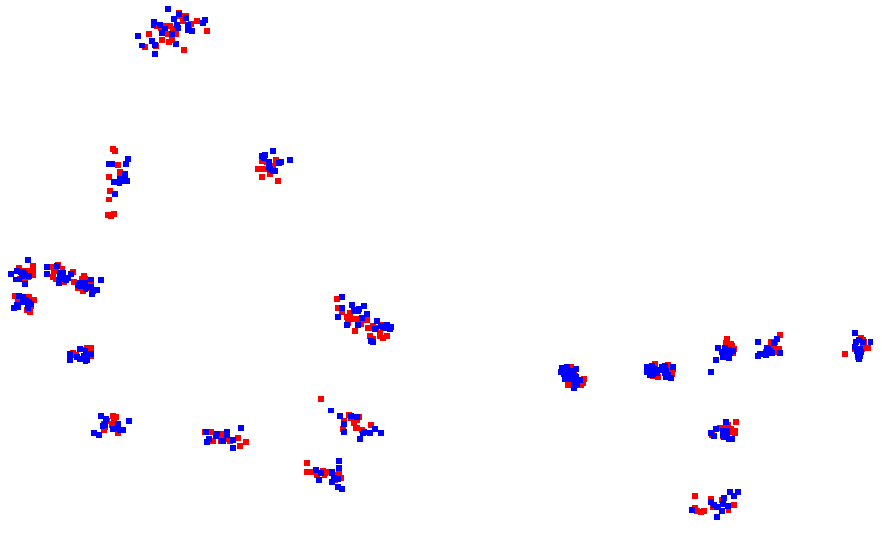 | 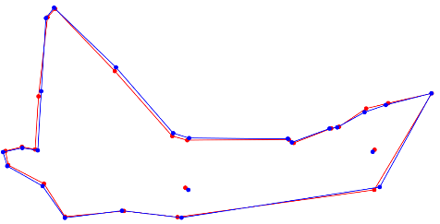
HVN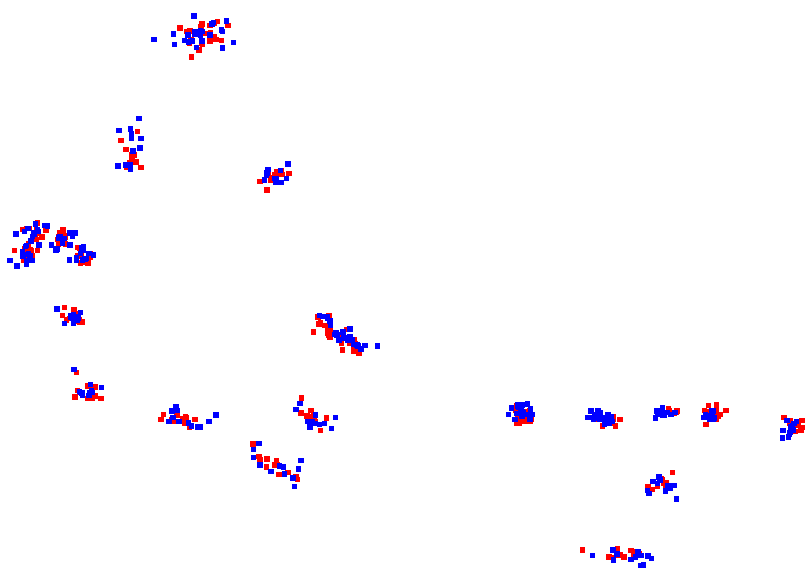 | 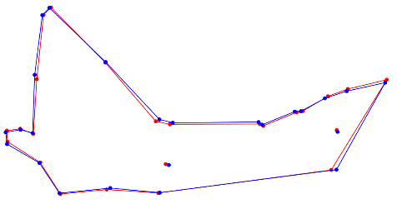
EVN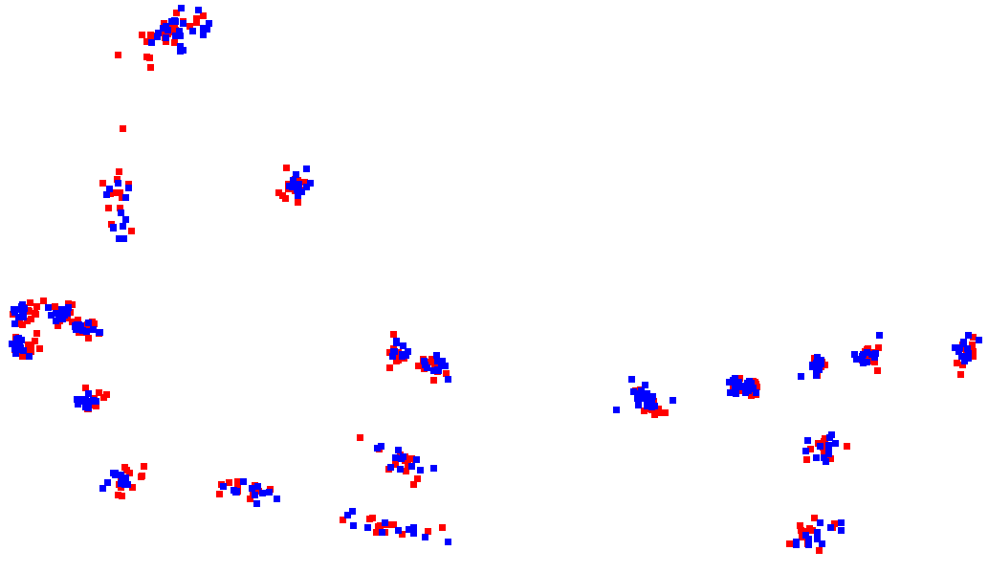 | 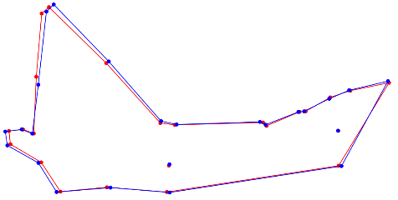
GV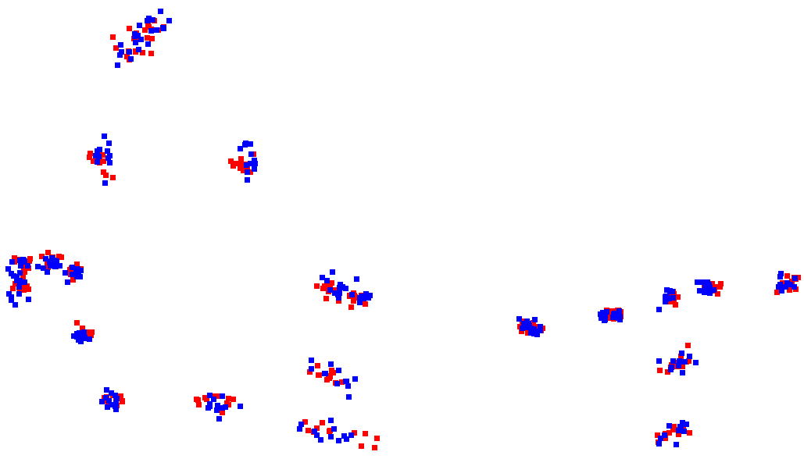 | 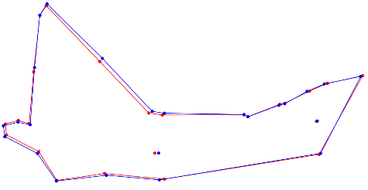
SI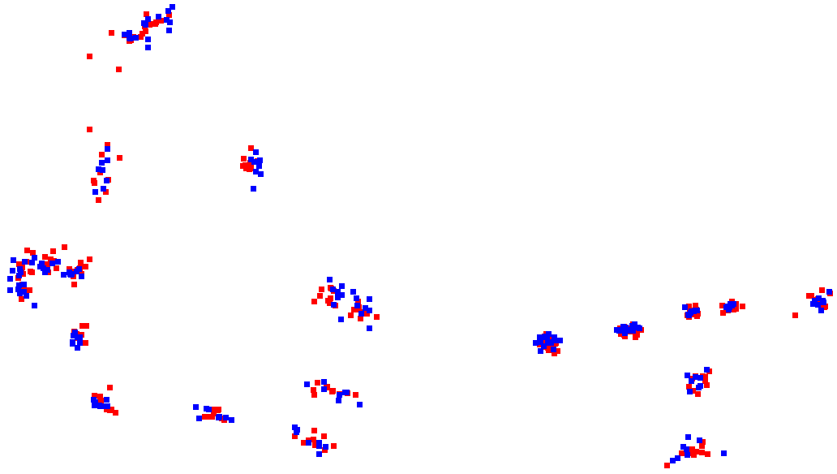 | 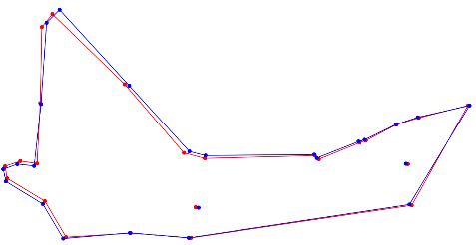
RI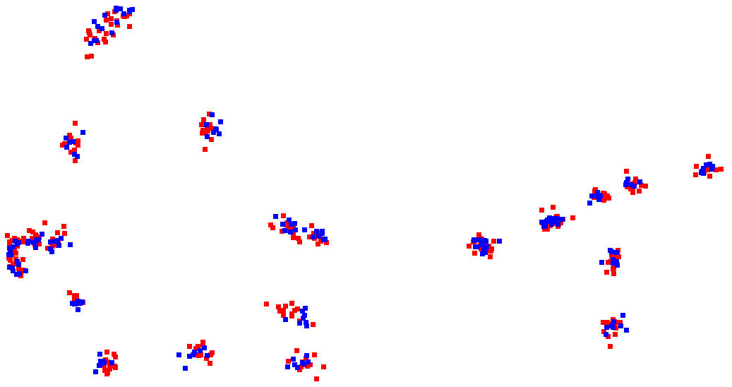 | 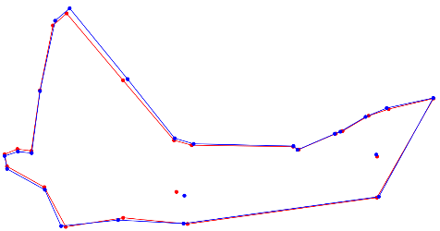
EN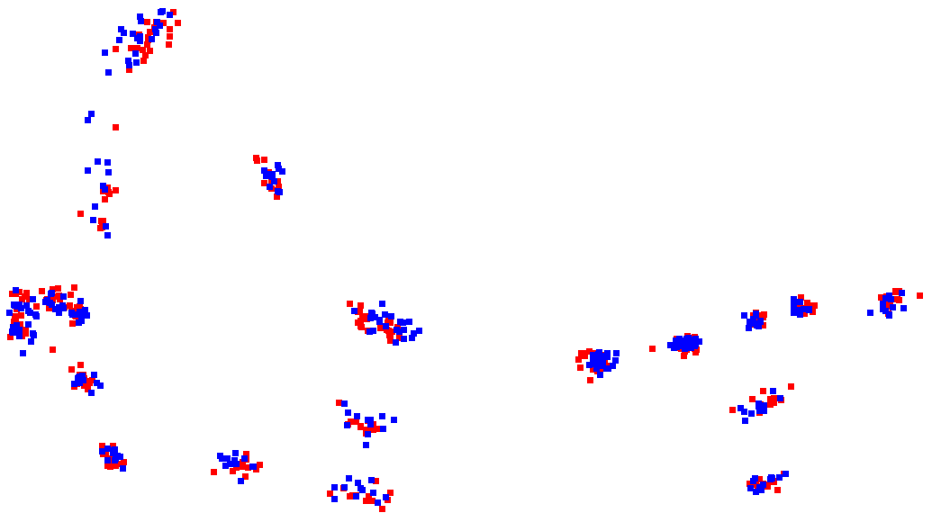 | 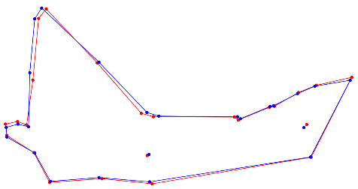
Figure 1.5. Composite figure of Procrustes superimpositions and Procrustes mean shapes of male and female stoats from 11 locations (10 New Zealand, 1 England). Males: blue, females: red.

Table 3. Within location discriminant function analysis of males and females, A) distances between means. B) Classification/misclassification analysis, percentage of misclassified individuals calculated from the cross validation tables, significant values (p<0.05) are highlighted in bold. This table includes Hollyford valley results from both prior to and after allometric correction.
A) |  |  |  |  |  |  | B)
 | Distance between means |  | Hotelling's T-square, parametric p-value | Permutation tests (10000 runs)
 | Procrustes | Mahalanobis |  | Procrustes | Hotelling's T-square
CP | 0.0164 | 3.2477 | 57.5328, 0.9842 | 0.4156 | 0.0147 | 9.0909 %
PU | 0.0285 | 3.7750 | 71.2544, 0.9530 | 0.0056 | 0.0009 | 10.0000 %
AP | 0.0237 | 3.9568 | 93.9383, 0.9666 | 0.0326 | 0.0275 | 37.5000 %
WL | 0.0202 | 5.0199 | 226.7988, 0.9695 | 0.0080 | 0.0170 | 38.8889 %
MC | 0.0197 | 5.0815 | 154.9288, 0.9090 | 0.0461 | 0.0034 | 20.8333 %
HVN prior to allometric correction | 0.0199 | 2.8559 | 48.9385, 0.9953 | 0.0974 | 0.3612 | 30.4348 %
HVN after allometric correction | 0.0423 | 7.3436 | 323.5709, 0.4998 | <0.0001 | 0.7643 | 56.5217 %
EVN | 0.0234 | 3.7628 | 88.3477, 0.9775 | 0.0343 | 0.0384 | 32.0000 %
GV | 0.0203 | 4.5892 | 126.3632, 0.9369 | 0.0567 | 0.0157 | 29.1667 %
SI | 0.0211 | 2.1211 | 19.9961, 0.9975 | 0.2178 | 0.7003 | 61.1111 %
RI | 0.0231 | 2.7562 | 37.6220, 0.9941 | 0.0006 | 0.1875 | 42.8571 %
EN | 0.0271 | 5.2554 | 165.7153, 0.8985 | 0.0256 | 0.0031 | 4.1667 %

