Symposium for W. Dickinson – SAA 2015

“Geological subsidence and sinking Islands: the case of Manono (Samoa)”
Christophe Sand¹, Jacques Bolé¹, David Baret¹, André-John Ouetcho¹, Fiona Petchey², Alan Hogg² Tautala Asaua³

Abstract
W. Dickinson, as part of his wide study of the geological history of the Pacific islands, has linked the unique case of the deeply submerged Lapita site of Mulifanua in Western Upolu (Samoa) to the slow subsidence of Upolu Island. Recent archaeological research on the neighbouring small island of Manono, has brought new and detailed data on this geological process. A series of new dates has allowed us to define the speed of the subsidence and demonstrate the massive environmental changes that the local population had to adapt to over the past 2500 years.
1. Institute of Archaeology of New Caledonia and the Pacific (IANCP)
2. Radiocarbon Dating Laboratory, University of Waikato
3. Center for Samoan Studies, National University of Samoa

Introduction
The geological diversity of the Pacific region defies any simple categorization. The region is divided between different tectonic plates and cut in two on its western side by the active “belt of fire”, with islands being derived from continental fragments to old eroding or still active volcanic summits to simple coral atolls. Volcanic activity, earthquakes and possible tsunami-related events, associated to episodes of extreme weather devastation through cyclones/typhoons or prolonged droughts make Oceania a region that often defies the idyllic image built by Western imagination. Amongst the different natural events that shape everyday life in the Islands, oral traditions for generations have transmitted stories of sinking and rising Islands (Nunn 2009). While some of these stories might be related to small isostatic sea level changes over time, the vast majority are unquestionably linked to tectonic activity. W. Dickinson, as a geologist, studied in detail the diversity of the geological building process of most of the archipelagos of the Pacific, explaining the structural specificities of each region though a number of scientific demonstrations. This paper would like to present an archaeological case of one of his most recently debated studies focused on the Upolu-Savai’i alignment forming the western part of Samoa in the central Pacific. After having synthesized the geological data on these two Islands and some archaeologically-related outcomes, we will outline the results of excavations undertaken on the small Island of Manono, positioned at the western point of the Upolu plate. These have demonstrated the progressive subsidence of this part of the archipelago, allowing for the first time to date precisely the chronology of this process over the nearly 3000 last years of human presence. The consequence of the progressive subsidence and the resilience of the local inhabitants to the loss of large expanses of arable land because of the “sinking Island”, will be discussed.

The geological setting of the Upolu-Savai’i Islands of Samoa
In Western Polynesia the archipelagos of Samoa, Tonga, Wallis-Futuna and Tokelau, have been defined as a coherent cultural entity (Burrows 1939), but the regions geology is characterized by only two contrasting geological structures. The region is divided by the Andesic Arc, that separates the subduction zone of the continental plate of the Western Pacific from the Oceanic plate on which are found only volcanic Islands. Most of the Tongan islands, as well as Fiji to the West, stand on the continental plate, separated from Samoa by the Tongan fault. The Samoan islands chain, which exceeds 1000km in length from Wallis (‘Uvea) Island in the west to Rose Atoll in the east, appear to result mainly from the volcanic activity of a “magmatic plume-driven hotspot” that progressively expands eastward due to the plate movement (Staudigel et al. 2006). The islands of Upolu Apolima and Savai’i are aligned in a south-east/north-west axis. No active volcano is today present on the 1119km² wide Upolu, but a number of former cones can easily be identified on the main axis of the Island, with the largest at 1100m (Mount Fito). This is in contrast to the island of Savai’i in the west, whose active craters continue to form the 1858m high Mount Silisili and 1707km² wide conic island. The origin of the recent volcanism on Savai’i is probably related to the relative migration of the edge of the Tonga trench (Hart et al. 2004). While the eastern part of the Upolu seashore is rugged, it’s western part is enclosed today by a reef with an extensive lagoon on its western point enclosing the small island of Manono. The cause of this reef formation has been attributed to the growing volcanic load of Savai’i creating a depression into which the western part of Upolu is slowly tilting (Dickinson 2007).
This geological subsidence process has resulted in a progressive loss of coastal flats, which has implications for archaeology since all first settlement sites as well as a large number of post-discovery settlements in the Pacific Islands have been in coastal locations. The implications of this for understanding past human settlement patterns was made evident by the discovery in 1973 of 2800 year old Lapita sherds buried 2.5m deep in the Mulifanua lagoon at the north-western tip of Upolu (Jennings 1974; Green and Richards 1975; Leach and Green1989; Petchey 2001). This unique example of a deeply buried first settlement occupation led W. Dickinson to use the archaeological site to refine geological chronology (Dickinson and Green 1998), allowing him to propose a subsidence process of about 1.1-1.4mm/year for this part of Samoa (Dickinson 2007). Expanding on this data, R.C. Green extrapolated on the possible locations of other early sites along the coasts of Samoa (Green 2002).

Testing the model: first results from Manono
Most researchers accept the basis of the model proposed by Dickinson to explain the geological setting of Upolu, a number of papers have recently addressed criticisms on different aspects of the model. One of the aspects highlighted is the speed of the tilting (Goodwin and Grossman 2003), another being the formation process of the Lapita layer of Mulifanua (Addison, perso. com. 2011). Recent archaeological data from the small Island of Manono enable us to address these issues.
Manono is positioned on the edge of the large lagoon that forms the western tip of Upolu, directly opposite Savai’I (fig. 1). It is a gently raised cone about 2.4km long and 1.8km wide, in the form of a large keyhole. The summit at about 60m altitude is the remnant of a former crater. Although of small size compared to its two large neighbours, Manono holds a prevalent position in the oral traditions of Samoa, having been a powerful political centre. Today the island is divided in two entities, Faleu/Lepuia’i in the southern half and Salua/Apai in the northern half. Settlements are restricted to the narrow coastal flats, as elsewhere in Samoa since European times (Davidson 1969), although a great number of former occupation remains are visible inland.
Between 2012 and 2015, a research program on the archaeology of Manono was carried out by the Institute of Archaeology of New Caledonia and the Pacific (IANCP) and the National University of Samoa. The main aim of the project was to study the former settlement patterns of the Island through mapping of surface sites and recording of the related oral traditions. As part of the overall understanding of the chronology of human occupation of the Island, excavations have been opened on the coastal flats of Salua village. Some of these have given a unique record on the geological subsidence process underway on Manono.

Excavation EX.1 of Pagai
Pangai is a coastal ridge on the east coast of Manono Island, directly facing the Lapita site of Mulifanua and the large lagoon of western Upolu. The site was chosen for excavation because it is the main sandy flat on this side of Manono, extending over more than 45m inland, with only a gentle rising slope at its back. The seashore is under severe erosion, with numerous stone artefacts found during surveys on the rocky beach at low tide. To test the model of a progressive subsidence of western Upolu, this appeared to be an ideal location. Moreover, the landowner informed us that earlier earth works for house-building had discovered large basaltic boulders in the sand. The 1m² test-pit EX. 1 was positioned at 20m from the eroding shore-cliff, with point 0 at 150cm over the main high tide level. The excavation led to the identification of 4 different episodes of formation of the site fill (fig. 2).
Layers 1-4: From the surface to about 45cm deep, the remains are related to post-contact settlement. Layer 3 is a paved surface of house platform. Layer 4 forms the fill of the house platform in which European items were found, as well as on the surface of the house floor.
Layers 5-8: From 45cm up to about 135cm, a series of distinct layers of sand characterize regular occupation of the area, under the sterile layer 5. Artefacts are nearly absent. A post-hole and a pit characterize the basal surface of layer 8.
Layer 9: Between about 135cm and 210cm there is a sterile sand layer containing only a few natural shells. To prevent the baulk collapsing, the excavation was reduced from this layer down, with only on a small central portion of the test-pit being investigated.
Layers 10 to 11: At 210cm, abruptly topped by the sand of layer 9 with no evidence of mixing, layer 10 is a compact dark soil. Its fill is characterized by the presence of potsherds, volcanic glass, fish bones and shell remains. The underlying layer 11 is of the same general clay texture but sits below the water table. Archaeological remains of the same type as in layer 10 are present. The excavation was stopped at 275cm deep without having reached the bottom of this layer.

The archaeological material
The complete record of the archaeological remains found in excavation EX.1 is presented in table 1. Unexpectedly, the sandy deposits are very poor in cultural material aside from shells. In the uppermost three layers of the excavation 4 metal needles, one cloth button and one porcelain marble were discovered. The only cultural material found in the lower part of the sand deposit (layer 8) was a small sized basalt adze (fig. 3). This overall absence of cultural remains contrasts with the data from the lower clay layers 10 and 11 where pottery and small volcanic glass flakes are present. The potsherds are mostly of small size, with a median thickness of about 4-7mm on average. The temper identified is only terrestrial. The outer colour of the sherds is brown, with only a few cases of blackened surface. The only two rim-types identified are straight and come from bowl shaped vessels of the Samoan thin ware type (fig. 3).
Bone fragments and crustacean pieces in low numbers were present in all the layers related to human presence, as well as one human tooth at 60-70cm. The shell data from EX1 shows a low proportion of shell remains, indicating mainly an opportunistic process of collection. Furthermore, the analysis shows a significant difference between the density of shell remains from the sand matrix and those in the clay matrix under the thick sterile sand fill (Layer 9). In the upper layers there is a rise in density of shells within each layer that is interpreted as occupation floors. Gastropods compose the highest amount of shells in the sandy layers, with Cerithium salebrosum (565g) presenting the highest amount, followed by Cypraeidae (310g), Trochidae (185g), Conidae (143g), Strobidae (91g) and Turbinidae (42g). Bivalves are represented near exclusively by Tridacnidae (111g) and Paphies striata (64g). Most importantly, considering the small size of the lower excavation trench for layers 10 and 11, the shell remains are in quantities about three to four times greater in the clay layers than in the sand layers above. A stronger reliance on shell consumption was though present during the first millennium BC on Manono. Only two species have been identified, Trochidae (98g) for the bivalves and Tridacnidae (90g) for the bivalves, taking into account that more than a third of the shells couldn’t be identified.

Dating sequence
The results from excavation EX.1 show clearly that Manono is slowly sinking. The oldest layers occupied by humans during the ceramic period are today under the water table. In order to get a better understanding of the chronology identified through the excavation, a series of samples collected from EX.1 were sent for dating. The results are presented in Table 2.
The upper most result (Wk-37438) confirms the modern date for the house platform found in layers 3-4. One sample from layer 8, the lowest human occupation of the sand fill gave an anomalous result of AD 1160-1260 (95% prob.). The other three dates for this layer fall between AD …? and ?....
range at 2 sigma (95% certainty) between 1281-1070 BP, though around 800 AD.
The sterile sandy layer has been dated on shell to AD 240-440. The top part of the clay layer, between 210-220cm, marking the appearance of pottery in the fill, is dated to 170-1 BC (Wk-37445).The underlying fill at 225cm is dated on shell to a calibrated range of 100-120 BC. The deepest sample that was able to be collected from EX.1, at 246cm before the appearance of the water, was dated to BC 360-110 (Wk-37447).

Analysis
The data from the test-pit excavation EX.1 undertaken at Pagai on the east coast of Manono, complemented by excavation EX.3 nearby (Sand et al. 2015), reveal a clear process of sedimentary change, from clayish soils to sand. At first human occupation, this area was clearly inland, with no close proximity of a sandy beach. Archaeological data suggest that the area was mainly used for some kind of human settlement, possibly a garden dwelling. The presence of numerous potsherds as well as volcanic glass and shells, indicates a continuous use of an inland location, at least starting by 2600-2700 cal. BP at EX.3. This is only about one century after the main Lapita settlement at Mulifanua (2880-2750 cal BP at 68% prob.), highlighting a rapid process of human settlement of Upolu and contradicting earlier hypothesis about a two-step occupation of Samoa (Addison and Matisoo-Smith 2010).

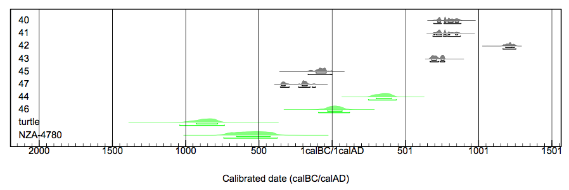
The encroachment of sand from the seashore is best demonstrated by the sterile layer 9 of excavation EX.1, which tops the soil layer without any process of mixing. A similar observation has been made in a number of other excavations fulfilled in Salua. This event occurred somewhere around the beginning of the first millennium AD. By associating this result with the dating of layer 8 at around 800 AD and considering that the soil surface has most probably been stable over the past three millennia, the subsidence rate of western limit of the Upolu plate is around 1.1-1.2mm/year; in keeping with rates proposed by W. Dickinson (2007). By 2800 BP when Samoa was first discovered by Lapita sailors, Manono was at the end of a large peninsula that covered part of what is today the Wasa lagoon. However, flat cultivable land originally extended over an area of at least 10km² (fig. 4), before its size shrank rapidly over the succeeding centuries, finally ending in the separation of Manono from Upolu.
The loss of a massive proportion of the cultivable soils trough the erosion of the flat plain must have fostered a radical although progressive change in settlement patterns for the groups centred on the small island. At EX.3, in the layer dated around 2000 BP, the presence of a set of large boulders placed in an alignment perpendicular to the seashore (Sand et al. 2015) might signal a first phase of land divisions through stone-walls, a tradition that is well identified in Western Polynesia in traditional times. The period around the beginning of the first millennium AD also marks the end of pottery production in Samoa as well as elsewhere in the West Polynesian region (Rieth and Hunt 2008). The data from the Manono excavations clearly point to the end of pottery production sometime around 1800-1700 cal BP, although no direct relationship between the subsidence process and the abandonment of ceramics in Samoa is to be expected.
By 1200 cal BP, when people started to use the now sandy flat of the Pagai plain, pottery use had vanished. Mapping of part of the inland area of Manono around Salua, has highlighted how much the succeeding millennium saw a massive intensification process of the land-use of the hillsides (Sand et al. 2015). This is identified by the dense array of walled enclosures with house platforms and roads covering the slopes leading to the central flattened hill-top. This central location of the island is itself covered with numerous platforms of a more ritual/political function: high stone platforms, star-mound shaped platforms, possible pigeon catching structures of Tongan type, raised roads, etc.. The hill itself is defended on most of its sides by a set of stone walls built along the cliff side or as proper structures, some reaching over 7m in high. All the ¹⁴C dates obtained from shells collected in the building material of these different structures, indicate that the main development of the Manono intensification process was confined to the second millennium AD. Clearly, the answer to land-loss due to geological tilting was in this case not abandonment of the Island but intensification of the land that was still present, in a process of resilience to environmental changes.

Conclusion
W. Dickinson has been instrumental in the use of geological data by archaeologists in the Pacific over the past 40 years. For Polynesia as well as Melanesia, his long-term commitment in understanding the subtle processes of land rise and subsidence that affected coastal areas since first human settlement, alongside isostatic fluctuations (Dickinson 2001) have been of critical importance for our understanding of archaeological site locations. Archaeological data are able to highlight with precision the geological processes identified, through the study and dating of human-related activities. It is an exercise of this type that has been proposed in this paper, allowing with the help of data from coastal excavations on the small Island of Manono, to propose a process of subsidence of the western part of Upolu at a rate of about 1.1-1.2mm/year. This is in line with what W. Dickinson had proposed through other data. The concluding outcome of this research is that geology and archaeology are in this case able to produce compatible results for a better and coherent understanding of Oceania’s past. Associated with sea-level fluctuations and sometimes massive erosional processes that have covered early settlement sites, the recent tectonic histories of the Pacific Islands are today one of the important natural hazards that archaeologists need to integrate into their analysis of former settlement patterns, to disentangle the complex processes of human occupations in the geologically active Islands chains of the wide Pacific plate.

Acknowledgments: The research on Manono presented in this paper would not have been conducted without the interest and support from the National University of Samoa, through the Center for Samoan Studies and his director Dr Leasiolagi Malama Meleisea. The staff at the Center, especially Taupa’ù Fiso Luatutu Evelini Faamoe and Lori Sciusco, as well as the students, must be thanked. On Manono, Luatutu Mao and his family were instrumental in opening the field for us in Salua and looking after us. The different families which granted us permission to work on their land must also be thanked. The financial support for this research, given by the New Caledonia Government and the French Pacific Fund, is deeply acknowledged.
C. Sand would like to thank W. Dickinson for his long-lasting interest in the archaeological research that he carries out in the Western Pacific. He first started exchanging letters with Bill in the late 1980s, as a young scholar trying to make sense of pottery types in Wallis and Futuna. Bill was kind enough to analyze a decade later some of our sherds from Cikobia island in North-eastern Fiji, complaining that we hadn’t had the good idea to sample the sand of each beach. He proposed a number of times to study the New Caledonia potsherds retrieved from our excavations, although it must be confessed that in most cases, we have still not finalized the papers/monographs that should have been published as an outcome. When Bill joined the conference celebrating the 50th anniversary of the first excavation at Lapita in 2002 in New Caledonia, we made sure to organize for him a visit to the Nickel mines on the peridotite plateaus of Grande Terre: seeing his excitement when he came back was so rewarding! After numerous other correspondences, it was though with great excitement that C. Sand wrote to him in late 2013 to inform him of the discoveries in Manono. He replied instantly, getting into geological details and calculations. Thanks to the invitation of David and Marshall to present this paper at the SAA session in San Francisco in April 2015, we had a last opportunity for a short discussion on the details of the Pagai results. As life follows sometimes strange paths, the team of the IANCP flue over Tongatapu on the 2nd of August 2015, on our way to Manono, just a few hours after Bill had been put into Polynesian soil for his eternal rest in Nukuleka. A last fa’afetai to a Big Man.

REFERENCES

Addison, D. and E. Matisoo-Smith, 2010. Rethinking Polynesian Origins: a West-Polynesia Triple-I Model. Archaeology in Oceania 45(1):1-12.
Bronk-Ramsey, C., 2015. OxCal Program v4.2, Radiocarbon Accelerator Unit. University of Oxford.
Burrows E.G. 1939. Western Polynesia: A Study in Cultural Differentiation. Ethnological Studies 7. Gothenburg.
Davidson, J. 1969. Samoan settlement patterns before 1840. Journal of the Polynesian Society 78(1): 44-82.
Dickinson, W.R. 2001. Paleoshoreline record of relative Holocene sea levels on Pacific Islands. Earth-Science Reviews 55: 191-234.
Dickinson W.R. 2007. Upôlu (Samoa): Perspective on Island Subsidence from Volcanic Loading. Journal of Island & Coastal Archaeology 2: 236-238.
Dickinson W.R. and R.C. Green, 1998. Geoarchaeological context of Holocene subsidence at the ferry berth Lapita site, Mulifanua, Upolu, Samoa. Geoarchaeology 13(3): 239-263.
Goodwin I.D. and E.E. Grossman, 2003. Middle to late Holocene castal evolution along the south coast of Upolu island, Samoa. Marine Geology 202: 1-16.
Green R.C. 2002. A retrospective view of settlement pattern studies in Samoa. In T.N. Ladefoged and M.W. Graves (eds), Pacific Landscapes: Archaeological Approaches, pp. 125-152. Los Osos: Easter Island Foundation.
Green, R.C. and H.G. Richards, 1975. Lapita pottery and a lower sea level in western Samoa. Pacific Science 29: 309-315.
Hart S.R., M. Coetzee, R.K. Workman, J. Blusztajn, K.T.M. Johnson, J.M. Sinton, B. Steinberger and J.W. Hawkins, 2004. Genesis of the Western Samoa seamount province: age, geochemical fingerprint and tectonics. Earth and Planetary Science Letters 227: 37-56.
Jennings J.D. 1974. The ferry berth site, Mulifanua District, Upolu. R.C. Green and J. Davidson (eds), Archaeology of Samoa (volume II), pp. 176-178. Auckland: Bulletin of the Auckland Institute and Museum 7.
Leach H.M. and R.C. Green, 1989. New Information for the Ferry Berth site, Mulifanua, western Samoa. Journal of the Polynesian Society 98: 319-329.
Patrick D. Nunn, 2009. Vanished islands and hidden continents of the Pacific. Honolulu : University of Hawaii Press.
Petchey, F.J. 2001. Radiocarbon determinations from the Mulifanua Lapita site, Upolu, western Samoa. Radiocarbon 43: 63-68.

Petchey, F., Anderson, A., Zondervan, A., Ulm, S., Hogg, A., 2008. New marine ∆R values for the South Pacific subtropical gyre region. Radiocarbon 50(3):373-397.
Reimer, P.J., Bard, E., Bayliss, A., Beck, J.W., Blackwell, P.G., Bronk Ramsey, C., Buck, C.E., Cheng, H., Edwards, R.L., Friedrich, M., Grootes, P.M., Guilderson, T.P., Haflidason, H., Hajdas, I., Hatté, C., Heaton, T.J., Hoffmann, D.L., Hogg, A.G., Hughen, K.A., Kaiser, K.F., Kromer, B., Manning, S.W., Niu M., Reimer, R.W., Richards, D.A., Scott, E.M., Southon, J.R., Staff, R.A., Turney, C.S.M., van der Plicht, J., 2013. IntCal13 and Marine13 radiocarbon age calibration curves, 0-50 000 years cal BP. Radiocarbon 55 (4):1869-1887.
Rieth T.M. and T.L. Hunt, 2008. A radiocarbon chronology for Samoan prehistory. Journal of Archaeological Science 35: 1901-1927.
Sand C. D. Baret, J. Bolé and A. Ouetcho, 2015. Manono Archaeology Project. Field Report 2014. Nouméa: Institute of Archaeology of New Caledonia and the Pacific Report.
Staudigel H., S.R. Hart, A. Pile, B.E. Bailey, E.T. Baker, S. Brooke, D.P. Connelly, L. Haucke, C.R. German, I. Hudson, D. Jones, A.A.P. Koppers, J. Konter, R. Lee, T.W. Pietsch, B.M. Tebo, A.S. Templeton, R. Zierenberg and C.M. Young, 2006. Vailulu’u seamont, Samoa: life and death of an active submarine volcano. Proceedings of the National Academy of Science USA 103: 6448-6453.

Manono 2013 Excavation EX 1 PAGAI (Samoa)
SPITS | GASTROPODS | BIVALVES | URCHINS | CORAL | BONES | CRUSTACEANS | Non diagnostic sherds* | Diagnostic sherds* | Lithics* | Metal | Other
0 - 10 |  |  |  |  | 55 |  |  |  |  | 4 needles | 1 button, 1 cement
10 - 20 | 107 | 36 |  |  | 22
20 - 30 | 60 | 26 |  |  | 34 | 1 |  |  |  |  | 1 porcelain marble
30 - 40 | 68 | 5 |  |  | 13
40 - 50 | 44 |  |  |  | 6
50 - 60 | 154 | 14 |  |  | 8 |  | 1
60 - 70 | 220 | 44 |  |  | 11 |  |  |  |  |  | 1 human teeth
70 - 80 | 170 | 40 |  |  | 15
80 - 90 | 102 | 26 |  |  | 8
90 - 100 | 144 | 8 |  |  | 10
100 - 110 | 340 | 60 |  |  | 13
110 - 120 | 224 | 68 |  | 78 | 15 | 1
120 - 130 | 190 | 25 |  |  | 6 |  |  |  | 1
130 - 140 | 145 | 49 |  | 22 | 6
140 - 150 | 96 | 9 |  |  | 8
150 - 160 | 60 | 5 |  |  | 10
160 - 170
170 - 180
180 - 190
190 - 200
200 - 210
210 - 230 | 156 | 48 | 3 | 115 | 6 | 10 | 19 | 1
230 - 250 | 191 | 34 |  | 290 | 5 | 4 | 9 |  | 2 |  | 2 obsidian flakes
250 - 265 | 116 | 12 | 4 |  | 7 |  | 7 | 1 | 5 |  | 3 obsidian flakes
265 - 275 | 6 |  | 1 | 56 | 2 | 12 | 2 |  | 1 |  | 1 flake

Table 1: Remains from excavation EX.1 at Pagai, Manono.

______________________________________________________________________
Sample ID | Lab number | Context | Material | δ¹³C  ±0.2‰ (IRMS)** | CRA (BP) | Calibrated age (68.2% prob.)^ | Calibrated age (95.4% prob.)^
IANCP-263 | Wk-37438* | ?? | Charcoal | -27.9 | 100.1 ± 0.3% | Modern | Modern
IANCP-265 | Wk-37440* | ?? | Charcoal | -25.4 | 1227 ± 20 BP | 720-870 AD | 690-880 AD
IANCP-266 | Wk-37441* | ?? | Charcoal | -24.1 | 1235 ± 20 BP | 690-860 AD | 680-750 AD
IANCP-267 | Wk-37442* | ?? | Charcoal | -25.6 | 834 ± 20 BP | 1180-1250 AD | 1160-1260 AD
IANCP-268 | Wk-37443 * | ?? | Charcoal | -25.8 | 1287 ± 20 BP | 680-770 AD | 660-770 AD
IANCP-269 | Wk-37444 | ?? | Shell: Tridacna sp. | 2.0 | 2061 ± 25 BP | 300-410 AD | 240-440 AD
IANCP-270 | Wk-37445* | ?? | Charcoal | -27.9 | 1971 ± 21 BP | 120-40 BC | 170-1 BC
IANCP-271 | Wk-37446 | ?? | Shell: Tridacna sp. | 2.1 | 2347 ± 25 BP | 40 BC-70 AD | 100 BC – 120 AD
IANCP-272 | Wk-37447* | ?? | Charcoal | -26.5 | 2155 ± 20 BP | 350-170 BC | 360-110 BC

Table 2. Results of the ¹⁴C samples of excavation EX.1 at Pagai.

* Radiocarbon dates measured by AMS at the Waikato Radiocarbon Dating Unit.
** Isotope ratio mass spectrometer value measured directly on CO₂ collected during combustion of sample for dating.
^ All radiocarbon dates were calibrated in OxCal v4.2 (Bronk Ramsey 2015) using the Marine13 and Intcal13 curves (Reimer et al. 2013). A location-specific reservoir correction value (∆R) of 28±26 ¹⁴C years has been applied to calibrations of the shells to adjust for regional oceanic variation in ¹⁴C (Petchey et al. 2008).

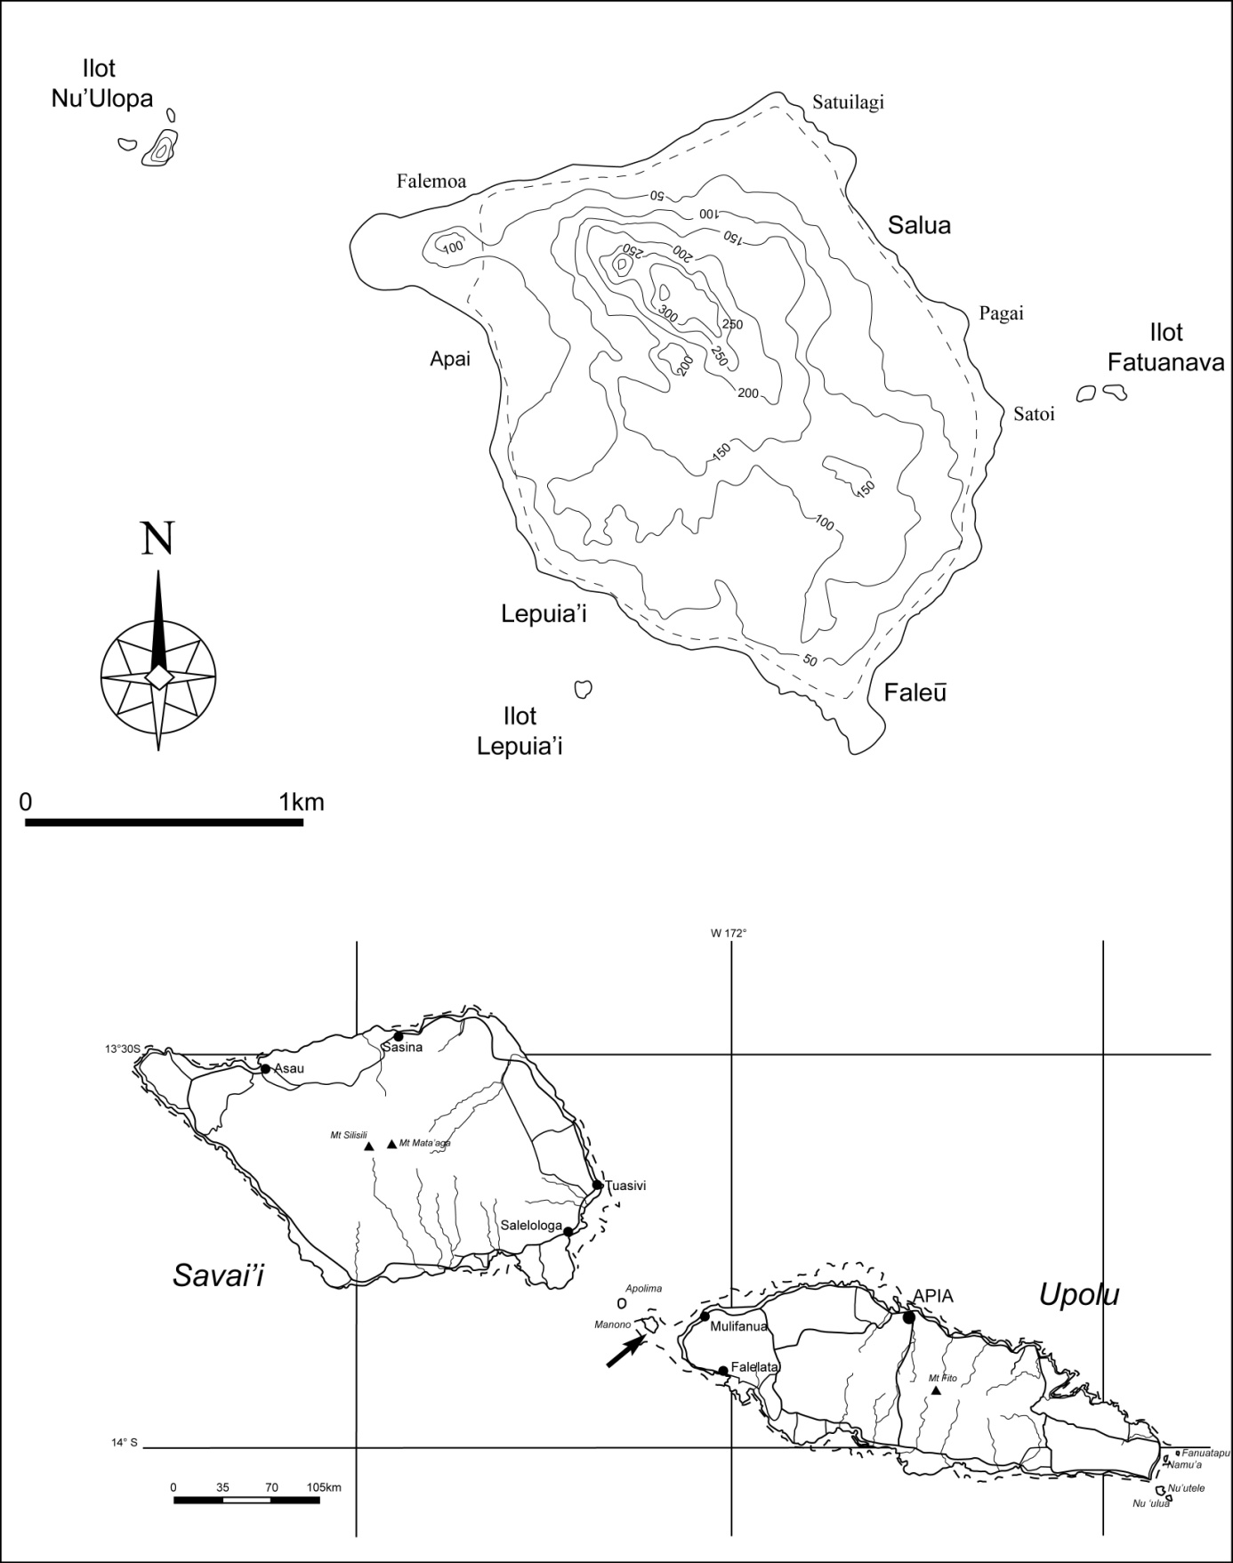

Figure 1. Position of Manono Island in between Savai’i and Upolu, and map of the Island locating the area of Pagai.

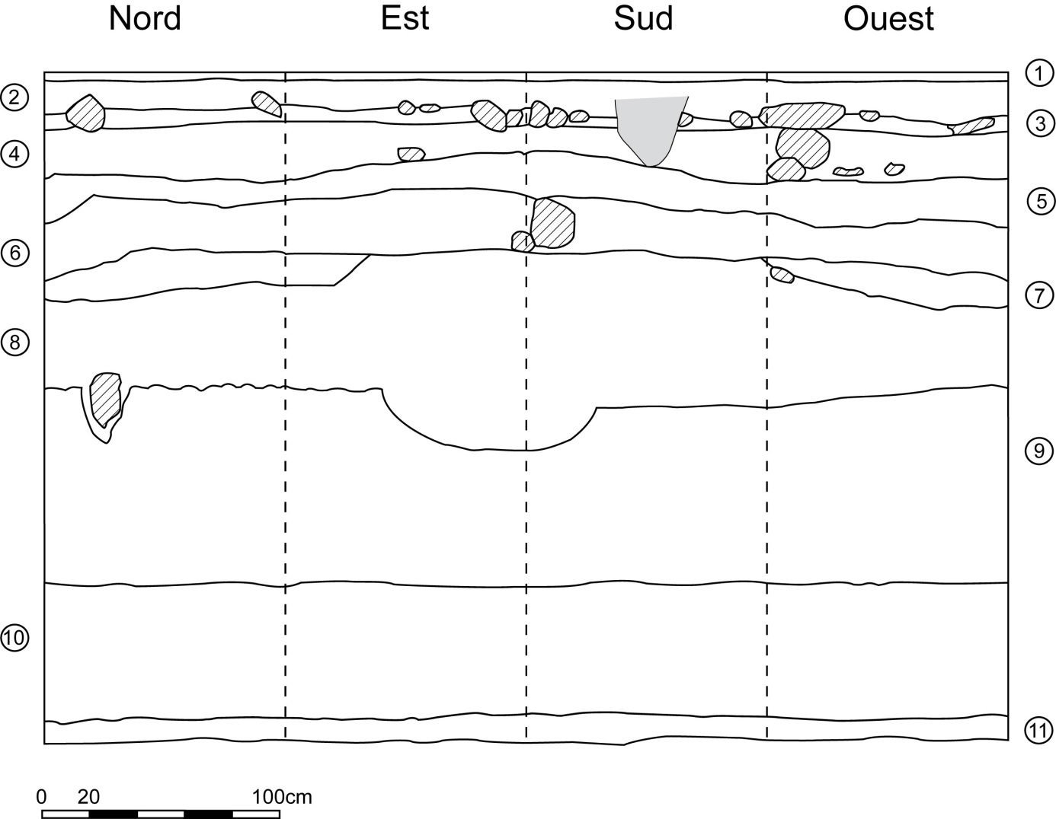

Figure 2. Stratigraphic profile of excavation EX.1 at Pagai.

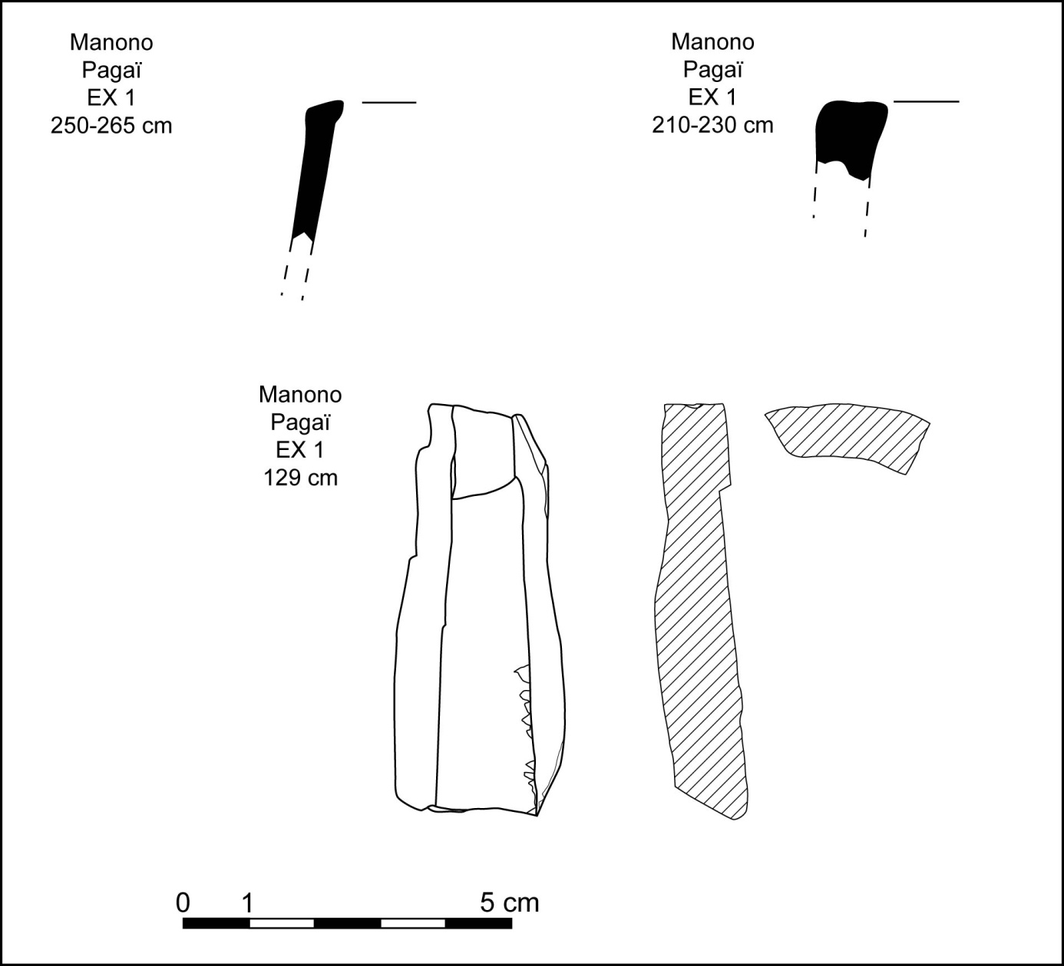
Figure 3. Rim sherds and adze fragment from excavation EX.1 at Pagai.

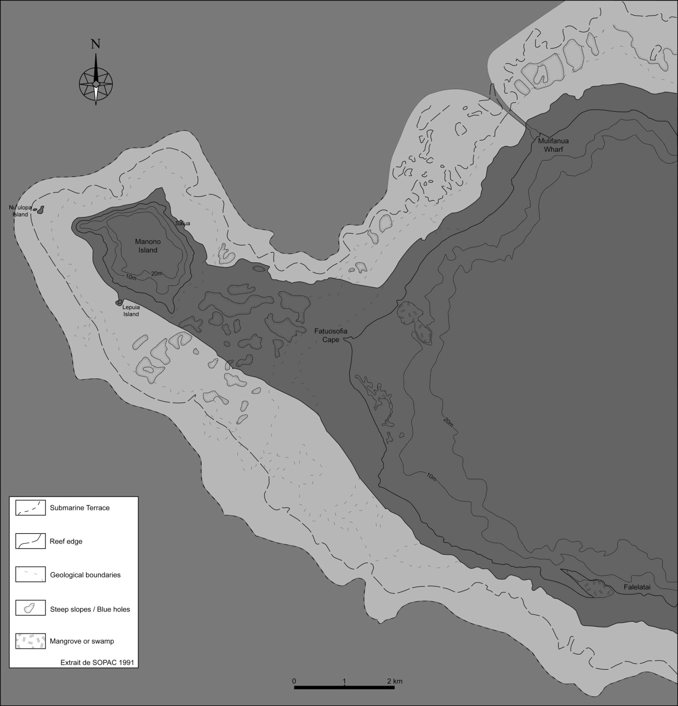
Figure 4. Broad coastal limits of the western end of Upolu at first human settlement of Samoa 2800 years ago.

