Appendix one

Interspecific morphological differences of New Zealand mustelid mandibles
Regression score 1 | 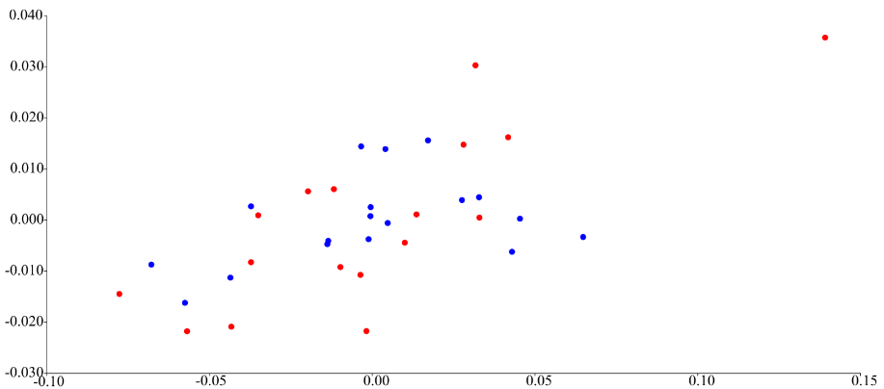
 | Log centroid size
Figure 1.1. Pooled-within group regression analysis of shape and log centroid size, as a test for allometry on male and female ferrets. The associated statistics can be found in Table 1. Males: blue, females: red.

Regression score 1 | 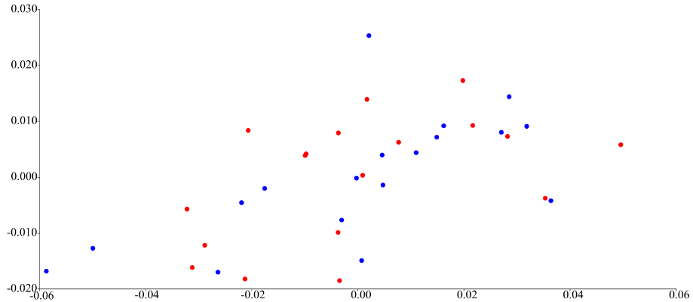
 | Log centroid size
Figure 1.2. Pooled-within group regression analysis of shape and log centroid size, as a test for allometry on male and female stoats. The associated statistics can be found in Table 1. Males: blue, females: red.

Regression score 1 | 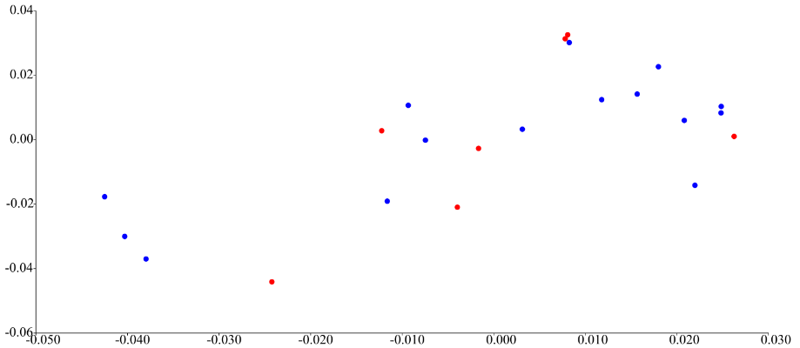
 | Log centroid size
Figure 1.3. Pooled-within group regression analysis of shape and log centroid size, as a test for allometry on male and female weasels. The associated statistics can be found in Table 1. Males: blue, females: red.

Table 1. Within species regression analysis. The predicted (%) is the percentage of shape accounted for by size. The permutation test against the null hypothesis of independence is presented, significant values (p<0.05) are highlighted in bold.
 | Total SS | Predicted SS | Residual SS | d.f. | % predicted | Permutation test p-value (10000 runs)
Ferrets | 0.0594 | 0.0026 | 0.0567 | 1, 33 | 4.4400 | 0.1525
Stoats | 0.0540 | 0.0015 | 0.0525 | 1, 34 | 2.7000 | 0.4983
Weasels | 0.0528 | 0.0043 | 0.0485 | 1, 20 | 8.1800 | 0.0566

Table 2. Within species discriminant function analysis, A) distances between means. B) Classification/misclassification analysis presented as the percentage of misclassified individuals calculated from the cross validation table.
A)
 | Distance between means |  |  | Hotelling's T-square, parametric p-value |  |  | Permutation tests (10000 runs)
 | Procrustes |  | Mahalanobis |  |  |  | Procrustes |  | Hotelling's T-square
Ferrets | 0.0258 |  | 10.4709 | 958.5647, 0.7058 |  |  | 0.0084 |  | 0.0007
Stoats | 0.0202 |  | 5.0199 | 226.7988, 0.9695 |  |  | 0.0080 |  | 0.0170
Weasels | 0.0311 |  | 5.6339 | 151.4894, 0.8802 |  |  | 0.0543 |  | 0.0003
B)
 |  | Ferrets |  |  | Stoats |  |  |  |  | Weasels
 |  | 20.0000 % |  |  | 38.8889 % |  |  |  |  | 18.1818 %

 |  | Developmental modularity | Functional modularity
Frequency. | Ferrets | 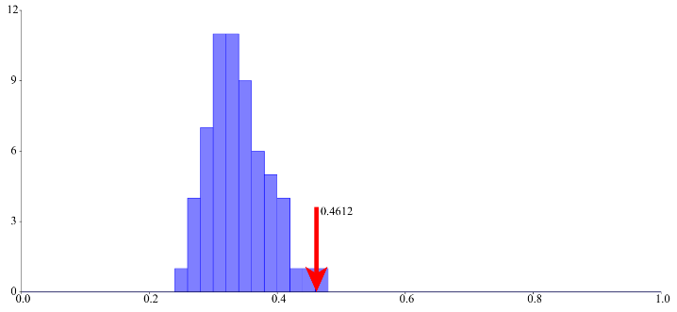 | 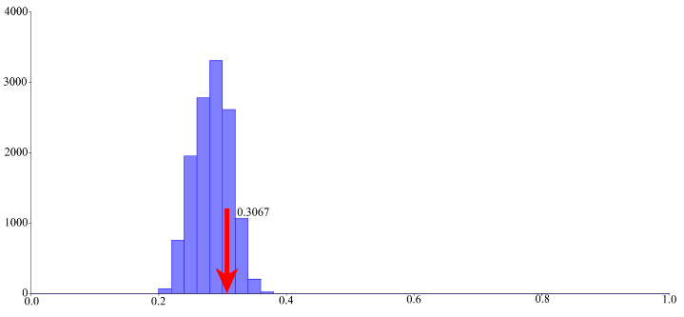
Frequency. | Stoats | 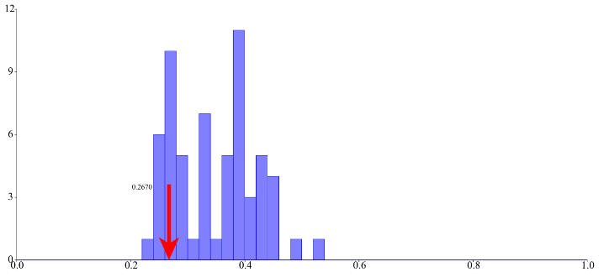 | 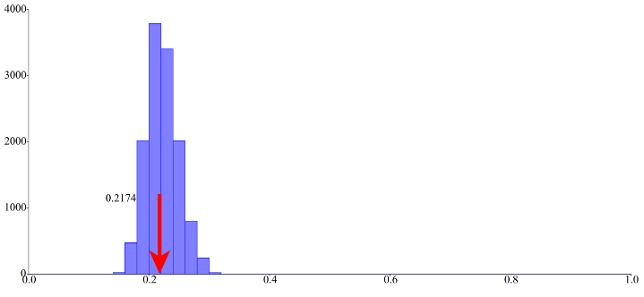
Frequency. | Weasels | 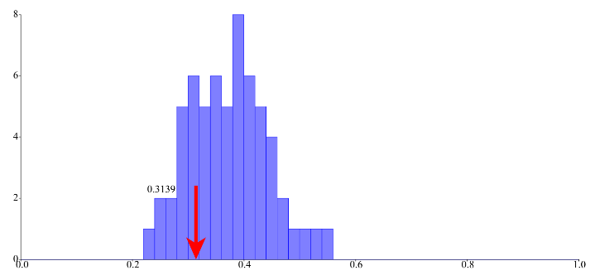 | 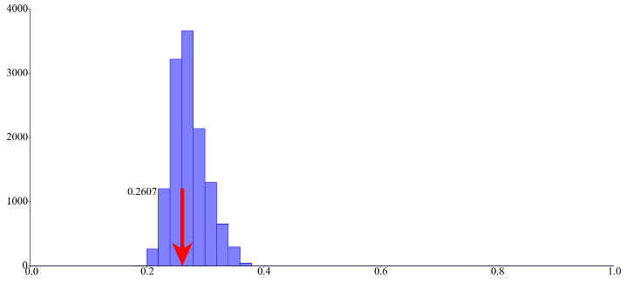
 |  | RV coefficient | Multi-set RV coefficient
Figure 1.4. Frequency distribution graphs from the modularity testing on the individual species. The red arrows indicate the RV coefficient for each hypothesis. None of the hypotheses were significant (p>0.05).

 |  | Developmental modularity | Functional modularity
Frequency. | Before allometric correction | 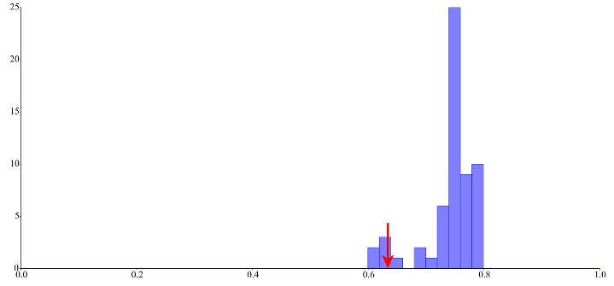
Frequency. | After allometric correction | 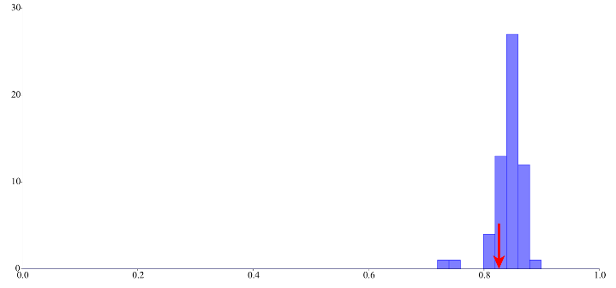 | 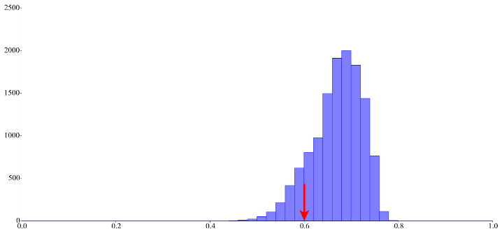
 |  | RV coefficient | Multi-set RV coefficient
Figure 1.5. Frequency distribution graphs from the modularity testing on the individual species. The red arrows indicate the RV coefficient for each hypothesis. None of the hypotheses were significant (p>0.05).

