Fitness of multidimensional phenotypes in dynamic adaptive landscapes

Daniel C. Laughlin¹ and Julie Messier²

¹ Environmental Research Institute and School of Science, University of Waikato, Private Bag 3105, Hamilton 3240, New Zealand
² Ecology and Evolutionary Biology, University of Arizona, 1041 E. Lowell Street, Tucson, AZ 85721, USA
*Correspondence: email d.laughlin@waikato.ac.nz, phone +64 7 858 5190

Abstract
Phenotypic traits influence species distributions, but ecology lacks established links between multidimensional phenotypes and fitness for predicting species responses to environmental change. The common focus on single traits rather than multiple trait combinations limits our understanding of their adaptive value, and intraspecific trait covariation has been neglected in ecology despite its importance in evolutionary theory and its likely impact on species distributions. Here, we extend the adaptive landscape framework to ecological sorting of multidimensional phenotypes across environments and discuss how two analytical approaches can be used to quantify fitness as a function of the interaction between the phenotype and the environment. We encourage ecologists to consider how phenotypic integration will constrain species responses to environmental change.

Key-words: adaptive landscapes; community ecology; fitness components; global change; intraspecific trait covariation; multivariate trait distributions; phenotypic integration; species distribution model
Glossary
Adaptive landscape: a framework in evolutionary biology for mapping fitness onto multivariate trait or gene combinations to understand how a phenotype evolves under selection.
Dynamic adaptive landscape: an ecological framework proposed here for quantifying how the shape of the adaptive landscape changes across environmental gradients. Its explicit handling of intraspecific covariation aids our understanding of how complex phenotypes are sorted along the gradients.
Environmental gradient: continuous variation in the level of resources (e.g. light) or conditions (e.g. temperature).
Intraspecific trait covariation: unstandardized correlation structure of traits among individuals within a population.
p_{max}: the direction of maximum phenotypic trait covariance, directly analogous to g_{max} in quantitative genetics.
Phenotypic integration: the pattern of functional, developmental, and/or genetic correlation among traits in a given organism.
Trait space: mathematical representation of all possible or observed combinations of trait values.

Traits and fitness in ecology
A major current challenge for population and community ecologists is to produce accurate forecasts of species and community-level responses to global change [1, 2]. Phenotypic traits have recently been heralded as the key to making generalizable predictions of community dynamics [3-6] and have achieved some success at predicting community composition [7, 8]. However, the rapidly growing field of trait-based ecology has emphasised the indirect link between traits and community dynamics without adequately resolving the important direct links between traits and fitness, which underpin the population dynamics that drive changes in community composition (Figure 1). Indeed, the integration of the fitness concept into species distribution models has only just begun [9-12] and clear empirical links between functional traits and fitness components are still rare [13, 14].
Population and species-level fitness differences are determined by differential rates of growth, survival, and reproduction (Figure 1) [15, 16], which ultimately lead to community dynamics on contemporary timescales and species sorting over environmental gradients [17, 18]. Quantifying the adaptive value of traits has been at the core of evolutionary biology for decades [15, 19, 20] and the multidimensional nature of phenotypic adaptation has been a central component of this theory [21, 22]. The overall aim of this review is to ground trait-based ecology in the foundational concept of fitness to improve predictions of species responses to the environment and to resolve the relationships between traits and fitness. This review is timely because the quantitative links between multidimensional phenotypes and fitness along many environmental gradients of importance to plants, animals, and microbes are still tenuous.
In this review we (i) discuss the importance of the multidimensional phenotype and intraspecific trait covariation, (ii) introduce the ‘dynamic adaptive landscape’ and (iii) discuss two empirical approaches to quantitatively link traits to fitness components. The dynamic adaptive landscape is an extension of the adaptive landscape framework in evolutionary theory to ecological sorting on the multivariate phenotype on an ecological scale. This framework provides a conceptual and analytical bridge between ecology and evolution and has strong potential to improve trait-based predictions of species responses because it explicitly considers how phenotypic integration and intraspecific trait covariation can constrain organism fitness along environmental gradients. We illustrate the tangible benefits of this new approach with a trait-based model to demonstrate how intraspecific trait covariance can constrain species distributions depending on how the phenotype maps onto the dynamic adaptive landscape.

The multidimensional phenotype and intraspecific trait covariation
Average trait values among species provide valuable information about where species are most likely to successfully grow, survive, and reproduce [23, 24]. Mean trait values are useful for many applications in ecology, but have inherent limitations for others. For example, when traits are used to quantify the niche of a species [25, 26], comparisons of simple vectors of mean trait values among species do not provide any information about niche breadth nor on how much niche overlap occurs among co-existing species [27-30]. This can be problematic because niche overlap is at the core of our understanding of species interactions, coexistence, community assembly, and species sorting [27, 31-34].
Recently revived interest in intraspecific trait variation has greatly complemented our understanding of average functional differences among species [28, 35-38]. The location (mean) of species in trait space (see Glossary) is arguably a critical moment in the trait distribution, but trait variation is also important because it affects both how a species responds to immediate changes to environmental conditions [39] as well as its evolutionary trajectory over time [40]. Two species with identical mean trait values will occupy different regions of a two-dimensional trait space if their trait variances differ (compare blue and orange species in Figure 2a). If species differ in their trait variances, this can indicate that one species has a greater diversity of genotypes or a stronger plastic response to the environment, and if the trait under study impacts the fitness of this species, then both genetic diversity and environmental plasticity will impact its potential distribution along an environmental gradient [41]. While trait means and variances are clearly important, we argue that these two ingredients alone are insufficient to quantify functional differences among species and cannot inform their dynamic evolutionary or ecological responses over time or across environmental gradients.
The third necessary ingredient is intraspecific trait covariation. Inter-specific trait covariation has underpinned the quantification of trait spectrums that reflect trade-offs among functions and strategy dimensions [42-45]. However, intra-specific trait covariation has received little attention despite its fundamental importance in determining fitness differences among species [46-49]. Individuals belonging to two species that have identical trait means and variances, but have opposite covariance, might occupy different regions of trait space (compare the green and red species in Figure 2a). Understanding intraspecific trait covariance is therefore just as important as estimating trait means and variances to describe the shape and space occupied by species within the available trait space [25]. Performance and fitness are best quantified by multiple integrated phenotypic traits [4, 50-52] because adaptation is a multivariate process [22] (Figure 1). While this has long been acknowledged by ecologists [53-56], it has not yet become an inherent part of the community ecologist’s toolbox in the same way it that it has pervaded the toolbox of the evolutionary biologist [20, 21]. Quantitative genetics has developed tools to study trait covariance within species because it can influence directional selection and hence the evolutionary trajectory of a species [15, 20, 22, 40, 57]. For example, the multivariate breeder’s equation predicts how population trait means will change over generations according to the heritability of the traits and the relationships between traits and fitness. A similar emphasis on intraspecific covariance is necessary for ecology to make accurate predictions of species responses to environmental change because environmental filtering is inherently a multivariate process.
The whole-organism phenotype is an integrated expression of multiple traits that are jointly influenced by developmental, genetic and environmental effects [58, 59]. Matrices of average functional traits among species are analogous to the interspecific genetic variance-covariance matrix (L) versus the intraspecific genetic variance-covariance matrix (G) in evolutionary biology [21, 58]. The ensemble of the L and G matrix, or their individual elements, do not necessarily need to be positively correlated because the forces shaping the genotypes among species can be different from those at play within species (Figure 2b) [60]. Generally, significant differences between interspecific and intraspecific genetic covariances (L and G, respectively) indicate the action of natural selection [58]. L and G are more likely to be similar if species have diverged solely by genetic drift [57, 61]. If we assume that interspecific trait covariance matrices (Q) and intraspecific phenotypic trait covariance matrices (P) are determined mostly by genes and less by the environment, which is a common simplifying assumption in these studies [58], then the same conclusions can be made about Q and P. Surprisingly few studies have actually compared the orientations of among- and within -species trait covariance matrices (Figure 2b) or the P matrices of different populations [62]. Most of these suggest that Q and P covariance matrices are similar in shape [58]. Many of these studies focused on a narrow range of phenotypic traits among and within species (Q and P, respectively) and were mostly size-related traits such as floral traits [63], beak dimensions [62], or cranial traits [64]. It is thus not surprising to find conserved allometry, since we might expect, for example, that flowers would maintain their proportionality to attract the right pollinators. Much less is known about how P and Q compare for non-allometric functional traits and for traits from different organs.
Recent work has shown that functional trait correlation patterns across species are not always found within species. For example, the leaf economics spectrum in plants represents a worldwide fundamental trade-off between rate of resource acquisition and leaf life span among species [43]. Species with rapid carbon assimilation rates at the leaf level tend to also have faster relative growth rates at the whole-organism level [65]. However, using a common garden experiment, it was shown that genotypes of cottonwood (Populus tremuloides) with more conservative leaf traits (i.e. longer leaf life spans and slower gas exchange rates) than other genotypes have faster whole-plant relative growth rates, driven by larger leaf area-to-sapwood area ratios [66]. This within-species relationship between leaf economics traits and relative growth rates is opposite to the pattern expected from the among-species pattern [65]. This indicates that we cannot always assume that P and Q covariance matrices are positively correlated (Figure 2b), as a third trait varying within species, such as leaf area-to-sapwood area ratio, can alter the relationship observed among species.
Empirical studies suggest that intraspecific patterns in trait covariation can also differ among species and from the global interspecific trends, as different mechanisms act at these vastly different scales. For example, mass-based leaf nitrogen concentration was not correlated with leaf mass per area within either Quercus ilex [48] or Pinus sylvestris [47], suggesting that individuals within species are not as linked in the expression of their physical and chemical leaf traits as detected in the strong worldwide interspecific correlation [43]. Population and species-level trait covariance structures have also been shown to differ in green finches [62]. A meta-analysis reported that differences in genetic covariance orientations occur in 25% of species comparisons [21]. These empirical studies illustrate that clarifying intraspecific trait covariance structure both within [48] and among organs [46, 49] is necessary to understand the adaptive value of trait combinations in different environments for predicting species responses to changing environmental conditions [48, 66].

Dynamic adaptive landscapes
Multiple phenotypic traits determine fitness and form the coordinates of adaptive landscapes in evolutionary theory [21, 57, 58]. This classic adaptive landscape framework examines the adaptive value of traits in a constant environment. For many ecological applications, in order to link traits to fitness we need to consider how adaptive landscapes change across environmental gradients [19]. Since the adaptive value of traits depends on the environmental context, adaptive landscapes are themselves dynamic and the location of fitness peaks change along environmental gradients.
We propose a ‘dynamic adaptive landscape’ framework for ecology to understand how the fitness of multidimensional phenotypes changes along environmental gradients. Illustrating this concept is challenging in multiple trait and environmental dimensions [19, 20], but can be simplified by representing a series of different adaptive landscapes along an environmental gradient for two traits (Figure 3). Let us consider the simplest scenario and assume that the adaptive value of two functional traits both increase along the environmental gradient so that ecological filtering favors a combination of low values for Traits 1 and 2 at the low end of the gradient (i.e. in Environment 1) and a combination of high values for Traits 1 and 2 at the high end of the gradient (i.e. in Environment 3) (Figure 3).
The breadth of species distributions will be affected by the direction of maximum intraspecific trait covariance (p_{max}) between these two traits within a population. Similar to how g_{max} determines how a population will evolve in an adaptive landscape over time [58], p_{max} will determine the distribution of a species along an environmental gradient. Consider the two species with opposite p_{max} in Figure 3. The trait covariance for the blue species parallels the changing adaptive peaks from the first through to the third environment, which means that the bivariate trait density of the blue species overlaps the peaks in the adaptive landscape across all three environments (Figure 3a-c). In contrast, the trait covariance for the gold species is perpendicular to the direction of change in the adaptive peaks, and so the bivariate trait density of the gold species only overlaps the peak in the adaptive landscape in the second environment (Figure 3a-c). These contrasting trait covariances have important implications for the constraints they impose on species distributions. The blue species will have a broader distribution than the gold species along the environmental gradient because its trait values overlap the fitness peaks in all three environments, whereas the gold species would be limited to the middle of the environmental gradient (Figure 3d). The key implication is that if a species’ traits strongly covary, then it will be able to tolerate a broad environmental gradient only if the covariance of those traits tracks the direction of change in the peak of the adaptive landscape over the environmental gradient. The strength of the covariance and the breadth of the variance of each trait are also important considerations because a species with a circular trait distribution (i.e. zero covariance) could also occupy a broader range on the adaptive landscape.
These theoretical predictions are supported by an objective Bayesian model of trait-based community assembly [7]. If the direction of maximum trait covariance (p_{max}) between two traits follows the same direction as the relationship between the adaptive value of the traits and the environmental gradient, then species can theoretically occur over a greater range along the gradient (see Box 1). In other words, p_{max} might have significant consequences on the environmental niche breadths of species (Box 1). These modelling results suggest that the accuracy of trait-based species distribution models will depend on the accuracy of our estimations of intraspecific trait covariation, and that the strength and sign of phenotypic integration will constrain how species respond to changing environmental conditions. The dynamic adaptive framework illustrates that intraspecific trait covariance dictates not only the potential evolutionary trajectory of a species [58] but also has important ecological consequences as it constrains a species’ ability to shift its range in response to environmental changes.

Linking the phenotype to fitness
Quantifying the fitness of multidimensional phenotypes along environmental gradients is the core empirical objective of the dynamic adaptive landscape framework. Here we describe two complementary methods: the ‘likelihood’ and ‘vital rates’ approaches (Table 1, Figure 4).
The ‘likelihood’ approach assigns a fitness value to traits using probability theory. With this approach, statistical models are used to regress trait values on environmental gradients to determine whether the expected mean trait values systematically change along the gradients. Significant trait-environment relationships imply that the adaptive value of the trait changes along the gradient. The majority of trait-based analyses in ecology over the last decade fall into this category. The adaptive value of the traits can be quantified as the likelihood of the traits in a given environment (i.e. P(Traits | Environment)). These probability densities look identical to the classic fitness function where fitness peaks at an optimal trait value (Figure 4). These trait-environment relationships have most commonly been assessed at the community level, using community-weighted mean trait values, where trait means are weighted by the relative abundances of species in the community. However, individual or population-level trait values can also be used to estimate likelihoods by quantifying how the frequency of phenotypes vary within species along environmental gradients [7].
The strength of the likelihood approach is that the data requirements are generally low (Table 1). To estimate the likelihood, one simply needs a snapshot of which trait values are found along the environmental gradient. In addition, current methods exist to link these likelihoods to predict species abundances in different environments [7] (Box 1). The method is easily extendable to multidimensional phenotypes by either using multivariate regression if the traits are correlated or separate regressions if the traits are independent [67]. However, a weakness of the likelihood approach is that it does not measure any fitness components directly (Table 1, Figure 4). Its core assumption is that the relative abundance of trait values in an environment reflects their adaptive value, i.e., traits of the most abundant individuals confer the highest fitness. This assumption might be reasonable under equilibrium conditions, but most communities are dynamic in space and time and trait distributions within communities can change over successional timescales [68]. Many of these dynamics are also driven by biotic interactions, and unless controlled experiments are conducted, disentangling the joint effects of abiotic environmental filtering from competitive and mutualistic interactions can be challenging [69, 70]. The predictable variation of trait values along environmental gradients that is often seen using the likelihood approach is assumed to occur because the dominant phenotypes have higher survival and reproduction in that environment [17]. Therefore, directly linking phenotypes to fitness is the next step to test this assumption.
The ‘vital rates’ approach models fitness components directly as a function of the interaction between traits and the environment (Figure 4, Table 1). This can be done at the individual- or population-level. Individual-level growth rate, survival, and reproduction are measures of performance, whereas population-level growth rates, survival rates, and reproductive rates are demographic vital rates (Figure 1). Consensus is starting to emerge that a few key functional traits can explain vital rates and life history strategies [14], setting the stage for a multi-trait approach. The few published studies that have linked traits to fitness have increased in complexity from those that related species-level average fitness components to functional traits independently of the environment [13, 71-78], to those that modelled individual-level growth and survival as functions of traits and the local environment [68, 79]. The importance of analysing the fitness of individual organisms within explicit environmental conditions was made clear by studies that showed that the growth-mortality trade-off among tropical forest trees appears only when focusing on smaller subsets of individuals growing at the extremes of the light gradient [13, 72]. Modelling fitness as a linear function of traits without a trait × environment interaction term would imply that some set of trait values can confer fitness in all environments, but trade-offs make the evolution of such a Darwinian demon an impossibility. The growth-mortality trade-off among shade-tolerant and light-demanding species is the best current example of trait-mediated fitness differences along a light availability gradient [13, 68, 80, 81]. This research agenda should be expanded to determine how functional traits determine fitness along other important gradients, such as resource gradients (prey abundance, nutrient availability) and non-resource gradients (temperature).
The strength of the vital rates approach is that it directly incorporates fitness components (Table 1, Figure 1). Trait × environment interactions can be estimated using any statistical model, whether the function models continuous or binary responses, such as growth rate and survival, respectively. To extend this approach to the multivariate phenotype, one can test for three-way trait × trait × environment interactions. The significance of these terms would indicate whether fitness in a given environment is determined by a particular trait combination. Flexible and powerful methods, such as Cox proportional hazards models, can be used for analysing how such interactions influence survival [82, 83]. However, unlike models developed under the likelihood approach [7, 8], we know of no models that can predict species distributions based on general predictions of fitness given a set of traits in a given environment. Some mechanistic models have modelled animal distributions using physiological tolerances that determine fitness under varying climatic conditions [9, 10, 12, 84]. However, in order for these mechanistic models to be generalizable, fitness components must then be linked to functional traits [11]. Development of such models is a high research priority.
Determining the adaptive value of the multivariate phenotype can be accomplished using both of these complementary approaches (Table 1, Figure 4). Given its lower data requirements, the likelihood approach is best for initial screening of which traits drive performance along environmental gradients and has led to important discoveries about how traits vary across landscapes. The vital rates approach is the logical next step to deepen our understanding of which trait combinations determine vital rates of growth, survival, and reproduction along environmental gradients. Large-scale observational approaches will be imporant, but experimental approaches will be especially useful to differentiate abiotic from biotic factors driving rates of growth, survival, and reproduction [85]. The dynamic adaptive landscape framework involves multiple traits from multiple individuals per species across environments. Therefore, Box 2 provides suggestions on to how to make decisions about the selection of the most relevant traits, the minimal sample sizes for estimating multivariate distributions, and the choice of species and ecosystems to prioritize.

Concluding remarks
There is mounting evidence of the importance of multidimensional phenotypes for understanding community assembly along environmental gradients [50] and species coexistence within communities [52]. Ecology’s Holy Grail is the ability to predict the fitness, and therefore abundance, of a phenotype with a, b, and c trait values in a site with x, y, and z environmental conditions [6]. Achieving this will enable ecologists to make more accurate forecasts of species range shifts at a global scale [1] but this will require the establishment of robust quantitative links between multidimensional phenotypes and fitness within varying environmental contexts.
The dynamic adaptive landscape framework provides a conceptual and analytical bridge between ecology and evolution to improve ecological prediction. Multivariate trait distributions can be used to determine how functional trade-offs within species can differ from trade-offs among species to improve our understanding of functional trait evolution [21] and the sorting of phenotypes across environmental gradients [34]. Knowledge of how trait covariance maps onto the dynamic adaptive landscape will enhance our predictions of species responses to changing conditions by linking traits directly to fitness components. We encourage ecologists to consider how phenotypic integration will constrain species responses to environmental change to strengthen the theoretical foundations of trait-based ecology. This new framework will not only provide clarity to unresolved relationships between multidimensional phenotypes and fitness (Figure 1), it will also enhance the success of conservation and restoration projects that face unprecedented challenges in a rapidly changing world.

Acknowledgements
This research was supported by a grant (UOW1201) from the Royal Society of New Zealand Marsden Fund. We thank Miguel Rivière for his assistance with analysing trait distributions and we thank Peter Adler for helpful discussions about these ideas. We thank John Dwyer and two anonymous reviewers for their constructive comments.

References
1. Williams, J.W., and Jackson, S.T. (2007) Novel climates, no-analog communities, and ecological surprises. Frontiers in Ecology and the Environment 5, 475-482
2. Thuiller, W. et al. (2008) Predicting global change impacts on plant species’ distributions: Future challenges. Perspectives in Plant Ecology, Evolution and Systematics 9, 137-152
3. McGill, B.J. et al. (2006) Rebuilding community ecology from functional traits. Trends in Ecology and Evolution 21, 178-185
4. Westoby, M., and Wright, I.J. (2006) Land-plant ecology on the basis of functional traits. Trends in Ecology and Evolution 21, 261-268
5. Weiher, E. et al. (2011) Advances, challenges and a developing synthesis of ecological community assembly theory. Philosophical Transactions of the Royal Society B: Biological Sciences 366, 2403-2413
6. Lavorel, S., and Garnier, E. (2002) Predicting changes in community composition and ecosystem functioning from plant traits: revisiting the Holy Grail. Functional Ecology 16, 545-556
7. Laughlin, D.C. et al. (2012) A predictive model of community assembly that incorporates intraspecific trait variation. Ecol. Lett. 15, 1291-1299
8. Shipley, B. et al. (2006) From plant traits to plant communities: A statistical mechanistic approach to biodiversity. Science 314, 812-814
9. Buckley, L.B. et al. (2010) Can mechanism inform species’ distribution models? Ecol. Lett. 13, 1041-1054
10. Kearney, M., and Porter, W. (2009) Mechanistic niche modelling: combining physiological and spatial data to predict species’ ranges. Ecol. Lett. 12, 334-350
11. Kearney, M. et al. (2010) Modelling the ecological niche from functional traits. Philosophical Transactions of the Royal Society B: Biological Sciences 365, 3469-3483
12. Sykes, M.T. et al. (1996) A bioclimatic model for the potential distributions of north European tree species under present and future climates. Journal of Biogeography 23, 203-233
13. Wright, S.J. et al. (2010) Functional traits and the growth–mortality trade-off in tropical trees. Ecology 91, 3664-3674
14. Adler, P.B. et al. (2014) Functional traits explain variation in plant life history strategies. Proceedings of the National Academy of Sciences 111, 740-745
15. Arnold, S.J. (1983) Morphology, performance and fitness. American Zoologist 23, 347-361
16. Violle, C. et al. (2007) Let the concept of trait be functional! Oikos 116, 882-892
17. Shipley, B. (2010) From plant traits to vegetation structure: chance and selection in the assembly of ecological communities. Cambridge University Press
18. Vellend, M. (2010) Conceptual synthesis in community ecology. The Quarterly Review of Biology 85, 183-206
19. MacColl, A.D. (2011) The ecological causes of evolution. Trends in Ecology & Evolution 26, 514-522
20. Phillips, P.C., and Arnold, S.J. (1989) Visualizing multivariate selection. Evolution 43, 1209-1222
21. Arnold, S.J. et al. (2008) Understanding the evolution and stability of the G-matrix. Evolution 62, 2451-2461
22. Blows, M.W. (2007) A tale of two matrices: multivariate approaches in evolutionary biology. Journal of Evolutionary Biology 20, 1-8
23. Grime, J.P. (1979) Plant strategies and vegetation processes. Wiley
24. Green, J.L. et al. (2008) Microbial biogeography: from taxonomy to traits. Science 320, 1039-1043
25. Violle, C., and Jiang, L. (2009) Towards a trait-based quantification of species niche. Journal of Plant Ecology 2, 87-93
26. Rosenfeld, J.S. (2002) Functional redundancy in ecology and conservation. Oikos 98, 156-162
27. MacArthur, R., and Levins, R. (1967) The limiting similarity, convergence, and divergence of coexisting species. American Naturalist 101, 377-385
28. Violle, C. et al. (2012) The return of the variance: intraspecific variability in community ecology. Trends in Ecology and Evolution 27, 244-252
29. Blonder, B. et al. (2014) The n-dimensional hypervolume. Global Ecology and Biogeography 23, 595-609
30. Hutchinson, G.E. (1957) Concluding remarks. In Cold Spring Harbor Symposia on Quantitative Biology, 415-427, Cold Spring Harbor Laboratory Press
31. Chase, J.M., and Leibold, M.A. (2003) Ecological niches: linking classical and contemporary approaches. University of Chicago Press
32. Chesson, P. (2000) Mechanisms of maintenance of species diversity. Annual Review of Ecology and Systematics 31, 343-366
33. HilleRisLambers, J. et al. (2012) Rethinking community assembly through the lens of coexistence theory. Annual Review of Ecology, Evolution, and Systematics 43, 227-248
34. Keddy, P.A. (1992) Assembly and response rules: two goals for predictive community ecology. Journal of Vegetation Science 3, 157-164
35. Albert, C.H. et al. (2011) When and how should intraspecific variability be considered in trait-based plant ecology? Perspectives in Plant Ecology, Evolution and Systematics 13, 217-225
36. Albert, C.H. et al. (2010) Intraspecific functional variability: extent, structure and sources of variation. Journal of Ecology 98, 604-613
37. Bolnick, D.I. et al. (2011) Why intraspecific trait variation matters in community ecology. Trends in Ecol. Evol. 26, 183-192
38. Jung, V. et al. (2010) Intraspecific variability and trait-based community assembly. Journal of Ecology 98, 1134-1140
39. Valladares, F. et al. (2007) Ecological limits to plant phenotypic plasticity. New Phytologist 176, 749-763
40. Steppan, S.J. et al. (2002) Comparative quantitative genetics: evolution of the G matrix. Trends in Ecology & Evolution 17, 320-327
41. Mazer, S., and Damuth, J. (2001) Evolutionary significance of variation. In Evolutionary ecology: concepts and case studies (Fox, C., Roff, D., and Fairbairn, D., eds), 16-28, Oxford University Press
42. Chave, J. et al. (2009) Towards a worldwide wood economics spectrum. Ecol. Lett. 12, 351-366
43. Wright, I.J. et al. (2004) The worldwide leaf economics spectrum. Nature 428, 821-827
44. Grime, J.P. et al. (1997) Integrated screening validates primary axes of specialisation in plants. Oikos 79, 259-281
45. Westoby, M. (1998) A leaf-height-seed (LHS) plant ecology strategy scheme. Plant and Soil 199, 213-227
46. Fajardo, A., and Piper, F.I. (2011) Intraspecific trait variation and covariation in a widespread tree species (Nothofagus pumilio) in southern Chile. New Phytologist 189, 259-271
47. Laforest-Lapointe, I. et al. (2014) Intraspecific variability in functional traits matters: case study of Scots pine. Oecologia 175, 1337-1348
48. Niinemets, Ü. (2014) Is there a species spectrum within the world-wide leaf economics spectrum? Major variations in leaf functional traits in the Mediterranean sclerophyll Quercus ilex. New Phytologist, In press
49. Richardson, S.J. et al. (2013) Intraspecific relationships among wood density, leaf structural traits and environment in four co-occurring species of Nothofagus in New Zealand. PLoS ONE 8, e58878
50. Laughlin, D.C. (2014) The intrinsic dimensionality of plant traits and its relevance to community assembly. Journal of Ecology 102, 186-193
51. Kleyer, M., and Minden, V. (2015) Why functional ecology should consider all plant organs: An allocation-based perspective. Basic and Applied Ecology 16, 1-9
52. Kraft, N.J. et al. (2015) Plant functional traits and the multidimensional nature of species coexistence. Proceedings of the National Academy of Sciences 112, 797-802
53. Bonser, S.P. (2006) Form defining function: interpreting leaf functional variability in integrated plant phenotypes. Oikos 114, 187-190
54. Levins, R. (1985) The dialectical biologist. Harvard University Press
55. Milla, R., and Reich, P.B. (2011) Multi-trait interactions, not phylogeny, fine-tune leaf size reduction with increasing altitude. Annals of Botany 107, 455-465
56. Craine, J.M. (2009) Resource strategies of wild plants. Princeton University Press
57. Lande, R. (1979) Quantitative genetic analysis of multivariate evolution, applied to brain: body size allometry. Evolution 33, 402-416
58. Merila, J., and Bjorkland, M. (2004) Phenotypic integration as a constraint and adaptation. In Phenotypic integration: studying the ecology and evolution of complex phenotypes (Pigliucci, M., and Preston, K., eds), 107-129, Oxford University Press
59. Pigliucci, M. (2003) Phenotypic integration: studying the ecology and evolution of complex phenotypes. Ecol. Lett. 6, 265-272
60. Cheverud, J.M. et al. (1989) Methods for the comparative analysis of variation patterns. Systematic Biology 38, 201-213
61. Zeng, Z.-B. (1988) Long-term correlated response, interpopulation covariation, and interspecific allometry. Evolution 42, 363-374
62. Merila, J., and Bjorkland, M. (1999) Population divergence and morphometric integration in the green-finch (Carduelis chloris) - evolution against the trajectory of least resistance? Journal of Evolutionary Biology 12, 103-112
63. Armbruster, W.S. (1991) Multilevel analysis of morphometric data from natural plant populations: insights into ontogenetic, genetic, and selective correlations in Dalechampia scandens. Evolution, 1229-1244
64. Cheverud, J.M. (1982) Phenotypic, genetic, and environmental morphological integration in the cranium. Evolution, 499-516
65. Lambers, H., and Poorter, H. (1992) Inherent variation in growth-rate between higher-plants - a search for physiological causes and ecological consequences. Adv. Ecol. Res. 23, 187-261
66. Grady, K.C. et al. (2013) Conservative leaf economic traits correlate with fast growth of genotypes of a foundation riparian species near the thermal maximum extent of its geographic range. Functional Ecology
67. Jamil, T. et al. (2013) Selecting traits that explain species–environment relationships: a generalized linear mixed model approach. Journal of Vegetation Science 24, 988-1000
68. Lasky, J.R. et al. (2014) Trait-mediated assembly processes predict successional changes in community diversity of tropical forests. Proceedings of the National Academy of Sciences 111, 5616-5621
69. Adler, P.B. et al. (2013) Trait-based tests of coexistence mechanisms. Ecol. Lett. 16, 1294-1306
70. Sears, A.L., and Chesson, P. (2007) New methods for quantifying the spatial storage effect: an illustration with desert annuals. Ecology 88, 2240-2247
71. Ozinga, W.A. et al. (2007) Local above-ground persistence of vascular plants: Life-history trade-offs and environmental constraints. Journal of Vegetation Science 18, 489-497
72. Poorter, L. et al. (2008) Are functional traits good predictors of demographic rates? Evidence from five Neotropical forests. Ecology 89, 1908-1920
73. Russo, S.E. et al. (2010) Interspecific relationships among growth, mortality and xylem traits of woody species from New Zealand. Functional Ecology 24, 253-262
74. Kitajima, K., and Poorter, L. (2010) Tissue-level leaf toughness, but not lamina thickness, predicts sapling leaf lifespan and shade tolerance of tropical tree species. New Phytologist 186, 708-721
75. Kraft, N.J.B. et al. (2010) The relationship between wood density and mortality in a global tropical forest data set. New Phytologist 188, 1124-1136
76. Martínez-Vilalta, J. et al. (2010) Interspecific variation in functional traits, not climatic differences among species ranges, determines demographic rates across 44 temperate and Mediterranean tree species. Journal of Ecology 98, 1462-1475
77. King, D.A. et al. (2006) The role of wood density and stem support costs in the growth and mortality of tropical trees. Journal of Ecology 94, 670-680
78. Osunkoya, O.O. et al. (2007) Variation in wood density, wood water content, stem growth and mortality among twenty-seven tree species in a tropical rainforest on Borneo Island. Austral Ecology 32, 191-201
79. Rüger, N. et al. (2012) Functional traits explain light and size response of growth rates in tropical tree species. Ecology 93, 2626-2636
80. Lusk, C.H., and Jorgensen, M.A. (2013) The whole-plant compensation point as a measure of juvenile tree light requirements. Functional Ecology 27, 1286-1294
81. F. J. Sterck et al. (2006) Leaf traits determine the growth-survival trade-off across rain forest tree species. The American Naturalist 167, 758-765
82. Broström, G. (2012) Event history analysis with R. CRC Press
83. Kleinbaum, D.G., and Klein, M. (2010) Logistic regression: a self-learning text. Springer
84. Robertson, M.P. et al. (2003) Comparing models for predicting species’ potential distributions: a case study using correlative and mechanistic predictive modelling techniques. Ecological Modelling 164, 153-167
85. Kraft, N.J.B. et al. (2015) Community assembly, coexistence and the environmental filtering metaphor. Functional Ecology 29, 592-599
86. Dray, S., and Legendre, P. (2008) Testing the species traits-environment relationships: the fourth-corner problem revisted. Ecology 89, 3400-3412
87. Dolédec, S. et al. (1996) Matching species traits to environmental variables: a new three-table ordination method. Environmental and Ecological Statistics 3, 143-166
88. Pollock, L.J. et al. (2012) The role of functional traits in species distributions revealed through a hierarchical model. Ecography 35, 716-725
89. Prentice, I.C. et al. (1992) Special paper: A global biome model based on plant physiology and dominance, soil properties and climate. Journal of Biogeography 19, 117-134
90. Kearney, M.R. et al. (2010) Correlative and mechanistic models of species distribution provide congruent forecasts under climate change. Conservation Letters 3, 203-213
91. Dwyer, J.M. et al. (2014) Specific leaf area responses to environmental gradients through space and time. Ecology 95, 399-410
92. Baraloto, C. et al. (2010) Functional trait variation and sampling strategies in species-rich plant communities. Functional Ecology 24, 208-216
93. Granier, C., and Vile, D. (2014) Phenotyping and beyond: modelling the relationships between traits. Current opinion in plant biology 18, 96-102
94. Houle, D. et al. (2010) Phenomics: the next challenge. Nature Reviews Genetics 11, 855-866
95. Fraley, C. et al. (2012) mclust Version 4 for R: normal mixture modeling for model-based clustering, classification, and density estimation. Technical Report No. 597. Department of Statistics, University of Washington

Table 1. Comparison of the likelihood and vital rates approaches for linking functional traits to fitness along environmental gradients. This is a central step in the dynamic adaptive landscape framework because it quantifies the shape of the adaptive landscape across environments.

 | Likelihood approach | Vital rates approach
The general model is… | Traits = f(Environment) | Fitness = f(Traits×Environment)
Link to fitness is… | Indirect: it assumes that the frequency of a trait value is a measure of its adaptive value | Direct
Data requirements are… | Lower: trait values in known environmental conditions | Higher: trait values in known environmental conditions and measures of performance over time
Temporal dynamics are… | Not incorporated | Implicit to the approach
Determining the optimal trait combination for a given environment is done by… | Using multivariate regression if traits are correlated, or separate regressions if traits are independent | Testing for Trait × Trait × Environment interactions
Methods to quantify the shape of the adaptive landscape across environments include… | - Generalized Linear Mixed Model  - Other models: Fourth-corner [86], RLQ [87], GLMM [67], hierarchical modelling [88] | - Generalized Linear Mixed Model  - Other models: Bayesian MCMC models [68], vital rate elasticities [14], Cox proportional hazards model [82, 83]
Proposed methods to predict trait-based species responses to the environment include… | - Predictive models of trait-based species distributions: CATS [8] and Traitspace [7] | - Mechanistic species distribution models [2, 9, 10, 12, 89, 90] based entirely on traits have yet to be generalised

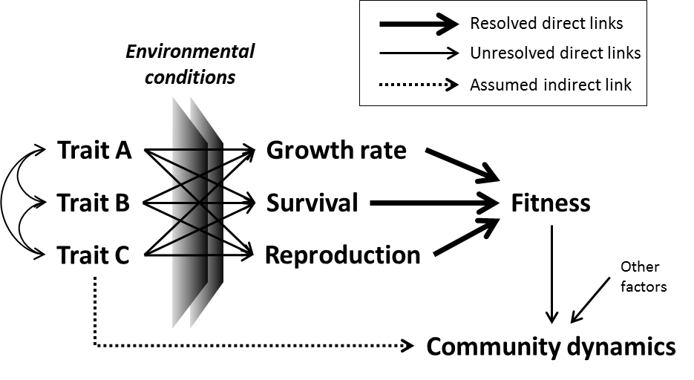
Figure 1. Path model, adapted from and inspired by Arnold [15], illustrating the hypothesized causal relationships between phenotypic traits, measures of performance, fitness, and community dynamics. Importantly, environmental conditions mediate the link between trait values and performance because one phenotype cannot be adapted to all environmental conditions. For clarity, this path model does not explicitly show how the environment can influence the expression of phenotypic traits in a given genotype. The curved arrows indicate the covariances among the traits, which further constrain how individuals perform in a given environment. Measuring fitness as lifelong reproductive output is ideal but is rarely possible, especially with long-lived organisms. Measures of individual organism performance, such as growth rate, survival, and reproduction are the proximate drivers of fitness. These performance measures can be scaled up to the population-level by calculating vital rates: population growth rate, survival rate, and reproductive rate. The rapidly growing field of trait-based ecology has emphasized the indirect link between traits and community dynamics without adequately resolving the important direct links between traits and fitness components that underpin many aspects of community dynamics.

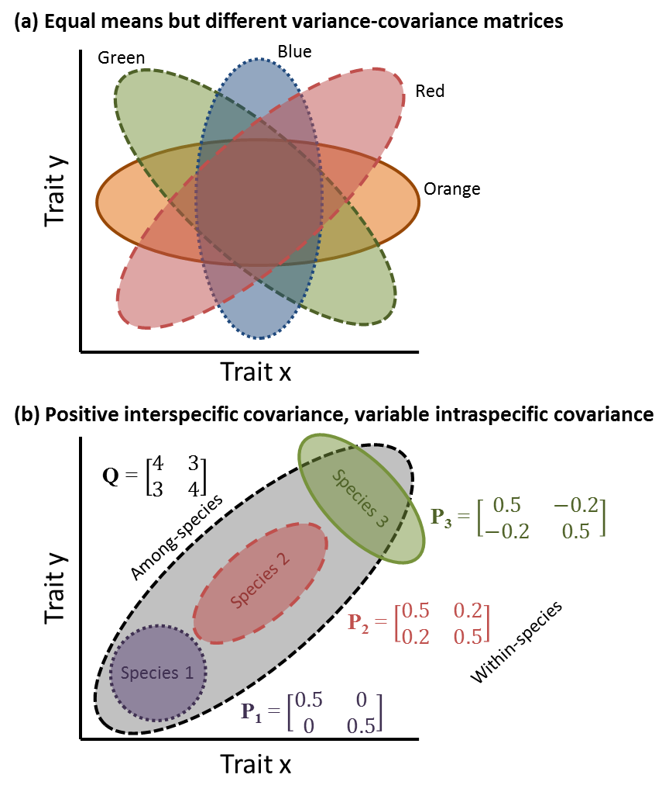
Figure 2. Intraspecific trait covariance is important for accurately quantifying how a species occupies trait space. (a) The orange and blue species have identical trait means, different trait variances, and zero covariance. The green and red species have identical trait means and variances, but opposite signs of trait covariation. (b) Illustration of the distinction between interspecific (among-species Q matrix) and intraspecific (within-species P matrix) trait covariation. Interspecific covariation is positive, but intraspecific covariation differs within each species. Trait covariance is zero for species 1. Trait covariance is positive for species 2 following the interspecific trait covariance pattern. Trait covariance is negative for species 3, which is opposite to the interspecific pattern.
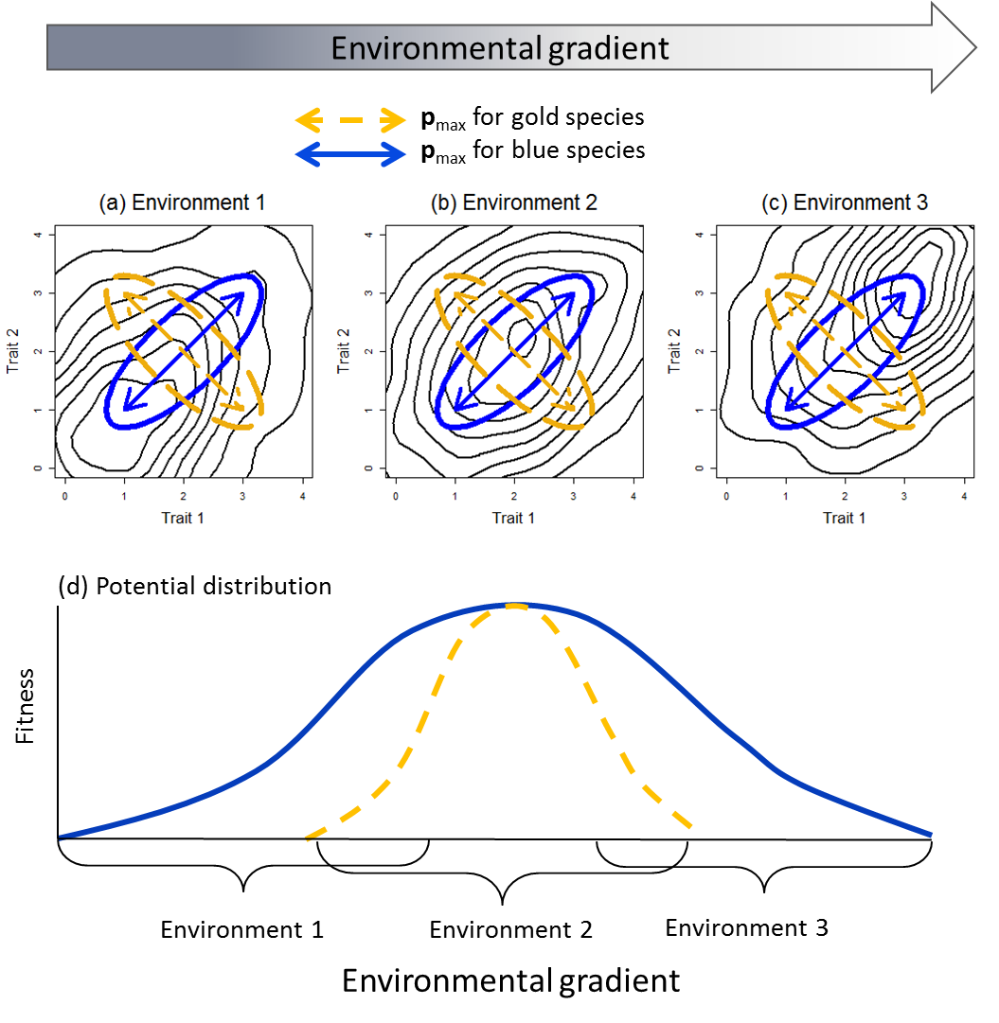
Figure 3. Dynamic adaptive landscapes allow the peaks of adaptive value (fitness) of phenotypic trait combinations to change in different environments (a-c). The contour lines indicate the fitness of individuals in bivariate trait space, where peaks indicate values of Traits 1 and 2 that confer greatest fitness in each of these environments. The direction of maximal trait covariance (p_{max}) for the blue species tracks the changing fitness peaks from (a) the first environment to (b) the second environment to (c) the third environment, which means that the bivariate trait density of the blue species overlaps the peaks in the adaptive landscape in all three environments. In contrast, p_{max} for the gold species is at odds with the direction of change in the adaptive peaks, and so the bivariate trait density of the gold species only overlaps the peak in the adaptive landscape in the second environment. (d) These differences have implications for predictions about the breadth of the environmental niches for these two species. A likelihood approach would predict that the blue species would have a broader environmental niche than the gold species.
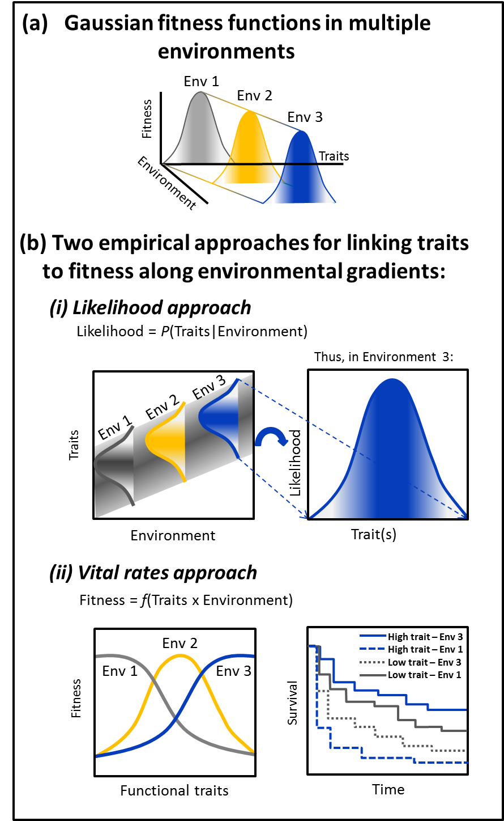
Figure 4. Linking phenotypic traits to fitness across environmental gradients. (a) The classic Gaussian fitness function shows that the adaptive value of traits changes along environmental gradients [19]. (b) Two empirical approaches can be used to link traits to fitness: (i) the ‘likelihood’ approach uses statistical regression models to find how the likelihood of a trait value changes across an environmental gradient, (ii) the ‘vital rates’ approach directly links a measure of performance (e.g. survival) to different combinations of trait values and environmental conditions.
<<<<<<<<<<< Begin Box 1 >>>>>>>>>>>>>>>>

Box 1. Effects of trait covariance on environmental niche breadth

The effects of trait covariance on fitness (based on trait frequencies) and the resulting species distributions along environmental gradients can be explored using the objective Bayesian model Traitspace. This model was developed to predict species distributions by combining two sources of information: intraspecific trait distributions and the relationship between individual-level traits and the environment [7]. Consider a simple scenario where two traits are positively correlated to an environmental gradient (Figure Ia,b), directly analogous to the example in Figure 3. This implies that high values of both traits are more adaptive and therefore confer greater fitness to individuals at the high end of the environmental gradient, but not at the low end. If we set the interspecific trait covariance to be positive, but vary the direction of intraspecific covariance, we can explore the effect of the direction of p_{max} relative to the orientation of the ridge in the dynamic adaptive landscape on the environmental niche breadth of each species. In the first scenario (Figure Ic), we set p_{max} to be parallel with the ridge of high fitness (analogous to the blue species in Figure 3). In the second scenario (Figure Ie) we set p_{max} to be perpendicular to the ridge of high fitness (analogous to the green species in Figure 3), but of equal magnitude to the first scenario.
In the first scenario, the intraspecific trait covariances are ‘tracking’ the positive relationship between the traits and the environmental gradient (Figure Ic), and so the variation of phenotypes within each species permits each species to occur across a greater breadth of environmental conditions (Figure Id). In the second scenario, the intraspecific covariances are perpendicular to the ridge of peak fitness in the adaptive landscape. The species environmental niche breadths are therefore constrained by the direction of phenotypic integration (Figure If) and fewer individuals exhibit the optimum combination of trait values. In other words, if the direction of maximum trait covariance (p_{max}) between the two traits follows the same direction as the relationship between the adaptive value of the traits and the environmental gradient, then species can theoretically occur over a greater range along the gradient.

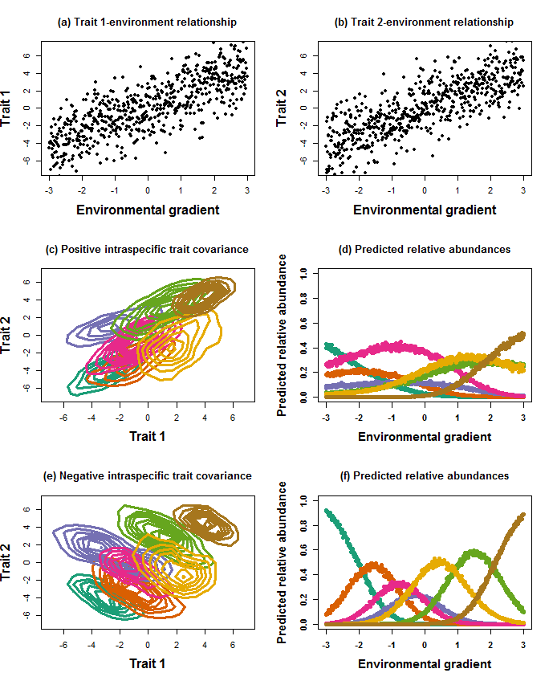
Figure I. The effect of intraspecific trait covariance on predicted species distributions and environmental niche breadth using the Traitspace model. In this analysis, both (a) trait 1 and (b) trait 2 at the individual level were positively associated with the environmental gradient. The means and variances of the traits for each species were held constant across both scenarios, but in (c) and (d) intraspecific trait covariance was positive, whereas in (e) and (f) intraspecific trait covariance was negative. Note how the predicted environmental niche breadths in (d) are generally larger than those in (f).
<<<<<<<< End of Box 1 >>>>>>>>>>
<<<<<<<< Begin Box 2 >>>>>>>>>>
Box 2: Logistical considerations and recommendations
Quantifying trait distributions of multiple species requires the measurement of multiple traits on multiple individuals of each species. Priority should be given to sampling traits from different functional dimensions from multiple organs to maximize the species’ functional niche represented by the traits measured [50-52]. Many traits (i.e. ‘soft traits’) are easy to measure; for example, morphological traits, are straightforward to measure on multiple individuals simultaneously while other traits (i.e. ‘hard traits’) such as physiological rates are more problematic.
Another important constraint is sample size. Sample size of traits is extremely variable across studies, and can range from one replicate per species [73] to over one hundred replicates per species [91]. Minimal sample sizes are important to accurately estimate covariances. To address this issue, we simulated thousands of trait distributions emulating real empirical distributions to determine how many individual samples were needed to accurately estimate the true mean and variance-covariance at least 90% of the time. At least 30 replicate individuals per species were needed to achieve 90% accuracy when estimating a one-dimensional normal trait distribution (Figure I). However, for estimating a three-dimensional trait distribution, at least 50 replicate individuals per species were needed to obtain 90% accuracy (Figure I). We might assume that this number continues to rise with increasing trait dimensionality and with departure from normality.
Sampling phenotypic traits can be time consuming and expensive [92]. Robust estimations of the mean, variance, and covariance of traits that span all functional organs and whole-organism properties might only be possible for a limited number of species and traits at first. Given these limitations, we recommend starting with studies that span a range of growth forms and biomes to determine the generality of functional trait covariance structures among species. The cutting-edge field of phenomics is rapidly developing technologies to quantify multidimensional phenotypes of individuals in controlled conditions, and these will no doubt increase our understanding of trait covariation [93, 94]. We might also want to focus on species that are at risk of extinction or those that are ecologically or commercially important. Quantitatively linking traits to fitness and applying the statistical tools at our disposal (Table 1) will advance our capacity to make robust predictions about how species will respond to environmental change, a fundamental goal of both basic and applied ecology.

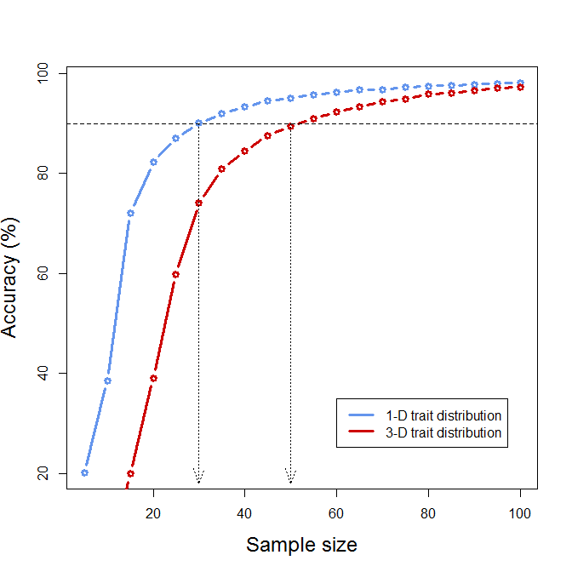
Figure I. The relationship between sample size per species and the accuracy of estimating the correct trait distribution. The following procedure was used to determine how many samples were needed to accurately estimate univariate and 3-dimensional trait distributions. First, for each trait or combination of traits and for each species, a Gaussian probability density function (PDF) [95] was fit to trait data. The trait distributions were drawn from a dataset that included three traits (specific leaf area, wood density, and bark thickness) measured on individuals on each of 17 tree species from Arizona, USA and New Zealand spanning a variety of climatic conditions. Second, for each tested sample size, where sample sizes were varied from 5 to 100 in multiples of 5, 500 sets of random samples were drawn from these fitted distributions. Third, PDFs were then fit to each of the random samples. Accuracy of a one-dimensional distribution was assessed by determining whether the estimated means and variances fell within their 95% confidence intervals based on the original data. Accuracy for the three-dimensional distributions required accurate estimations of two criteria: whether the estimated means fell within their 95% confidence intervals based on the original data, and whether the covariance structure was correctly determined. Ten different covariance structures are possible based on whether the distributions are spherical, diagonal, or ellipsoidal, and whether the volumes, shapes, and orientations are equal or variable [95].

<<<<<<<< End of Box 2 >>>>>>>>>>

